Table 1
Connections over 200 kbps in at Least One Direction 2008-2012
(In thousands)

 | 2008 |  | 2009 |  | 2010 |  | 2011 |  | 2012
Technology | Jun | Dec | Jun | Dec | Jun | Dec | Jun | Dec | Jun
Total | 132,814 | 102,239 | 119,433 | 136,294 | 157,017 | 182,065 | 206,131 | 230,387 | 243,397
Total Fixed | 73,123 | 75,707 | 77,997 | 79,994 | 81,764 | 84,521 | 86,575 | 88,320 | 89,959
Mobile Wireless¹ | 59,691 | 26,532 | 41,436 | 56,300 | 75,253 | 97,544 | 119,556 | 142,066 | 153,438

Table 2
Connections at Least 3 Mbps Downstream and 768 kbps Upstream 2008-2012
(In thousands)

 | 2008 | 2009 |  | 2010 |  | 2011 |  | 2012
Technology | Dec | Jun | Dec | Jun | Dec | Jun | Dec | Jun
Total | 31,120 | 33,332 | 40,669 | 45,552 | 55,110 | 64,819 | 82,013 | 100,271
Total Fixed | 30,987 | 33,108 | 38,963 | 41,364 | 44,694 | 48,577 | 51,095 | 57,247
Mobile Wireless¹ | 133 | 224 | 1,706 | 4,188 | 10,416 | 16,242 | 30,918 | 43,025

Table 3
Residential Connections over 200 kbps in at Least One Direction 2008-2012
(In thousands)

 | 2008 |  | 2009 |  | 2010 |  | 2011 |  | 2012
Technology | Jun | Dec | Jun | Dec | Jun | Dec | Jun | Dec | Jun
Total | 79,090 | 88,190 | 103,300 | 117,089 | 132,567 | 149,441 | 171,773 | 186,702 | 196,704
Total Fixed | 67,554 | 69,047 | 71,509 | 73,394 | 75,251 | 76,918 | 78,906 | 80,709 | 82,233
Mobile Wireless¹ | 11,536 | 19,142 | 31,791 | 43,695 | 57,316 | 72,523 | 92,867 | 105,993 | 114,472

Table 4
Residential Connections at Least 3 Mbps Downstream and 768 kbps Upstream 2008-2012
(In thousands)

 | 2008 | 2009 |  | 2010 |  | 2011 |  | 2012
Technology | Dec | Jun | Dec | Jun | Dec | Jun | Dec | Jun
Total | 29,127 | 31,356 | 38,426 | 42,243 | 47,632 | 51,783 | 63,734 | 78,616
Total Fixed | 29,013 | 31,161 | 36,844 | 39,037 | 41,769 | 45,263 | 47,425 | 53,077
Mobile Wireless¹ | 114 | 196 | 1,582 | 3,206 | 5,863 | 6,520 | 16,309 | 25,539

¹ Reporting instructions for mobile wireless changed between the June 2008 and December 2008 data. See Technical Notes at the end of the report.
Note: Some historical data have been revised. Figures may not sum to totals due to rounding.
Source: FCC Form 477, Parts I and VI.

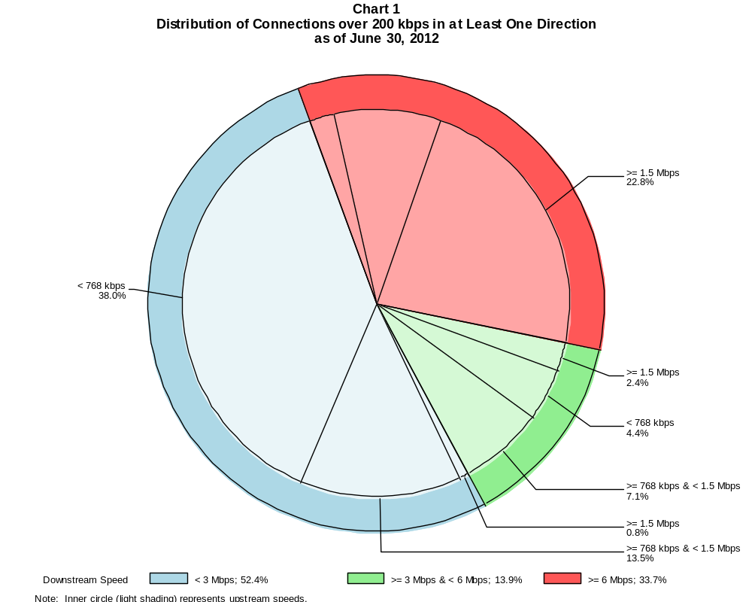

Connections over 200 kbps in at Least One Direction (in thousands)

 | Downstream Speed
Upstream Speed | Less than 3 Mbps | At least 3 Mbps  and less than 6 Mbps | At least 6 Mbps | Total
Less than 768 kbps | 92,545 | 10,624 | 5,021 | 108,189
At least 768 kbps & Less than 1.5 Mbps | 32,945 | 17,351 | 21,508 | 71,804
At least 1.5 Mbps | 1,991 | 5,873 | 55,539 | 63,404
Total | 127,481 | 33,848 | 82,068 | 243,397

Percentages

Less than 768 kbps | 38.0 | 4.4 | 2.1 | 44.4
At least 768 kbps & Less than 1.5 Mbps | 13.5 | 7.1 | 8.8 | 29.5
At least 1.5 Mbps | 0.8 | 2.4 | 22.8 | 26.0
Total | 52.4 | 13.9 | 33.7 | 100.0

Note: Figures may not sum to totals due to rounding.
Source: FCC Form 477, Part I.

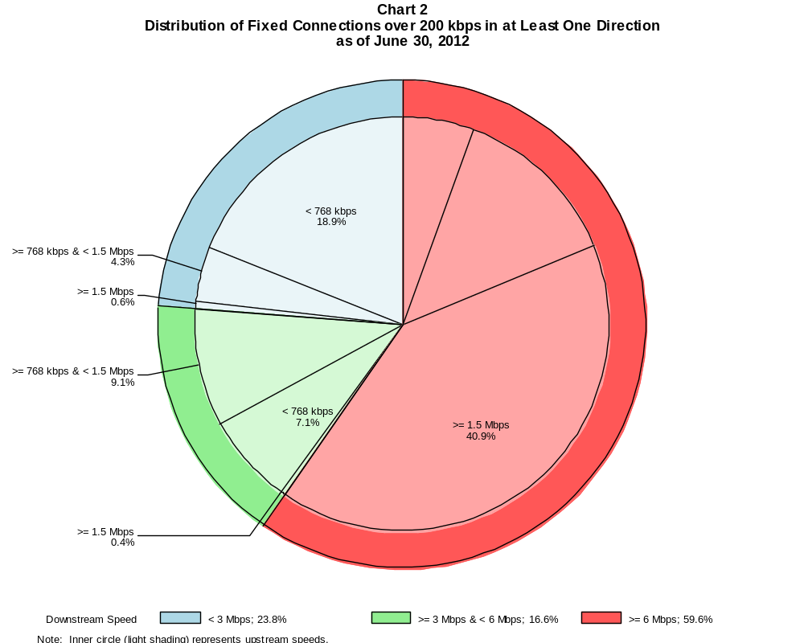

Fixed Connections over 200 kbps in at Least One Direction (in thousands)

 | Downstream Speed
Upstream Speed | Less than 3 Mbps | At least 3 Mbps  and less than 6 Mbps | At least 6 Mbps | Total
Less than 768 kbps | 16,962 | 6,353 | 4,987 | 28,302
At least 768 kbps & Less than 1.5 Mbps | 3,830 | 8,231 | 11,879 | 23,940
At least 1.5 Mbps | 581 | 347 | 36,790 | 37,717
Total | 21,372 | 14,931 | 53,656 | 89,959

Percentages

Less than 768 kbps | 18.9 | 7.1 | 5.5 | 31.5
At least 768 kbps & Less than 1.5 Mbps | 4.3 | 9.1 | 13.2 | 26.6
At least 1.5 Mbps | 0.6 | 0.4 | 40.9 | 41.9
Total | 23.8 | 16.6 | 59.6 | 100.0

Note: Figures may not sum to totals due to rounding.
Source: FCC Form 477, Part I.

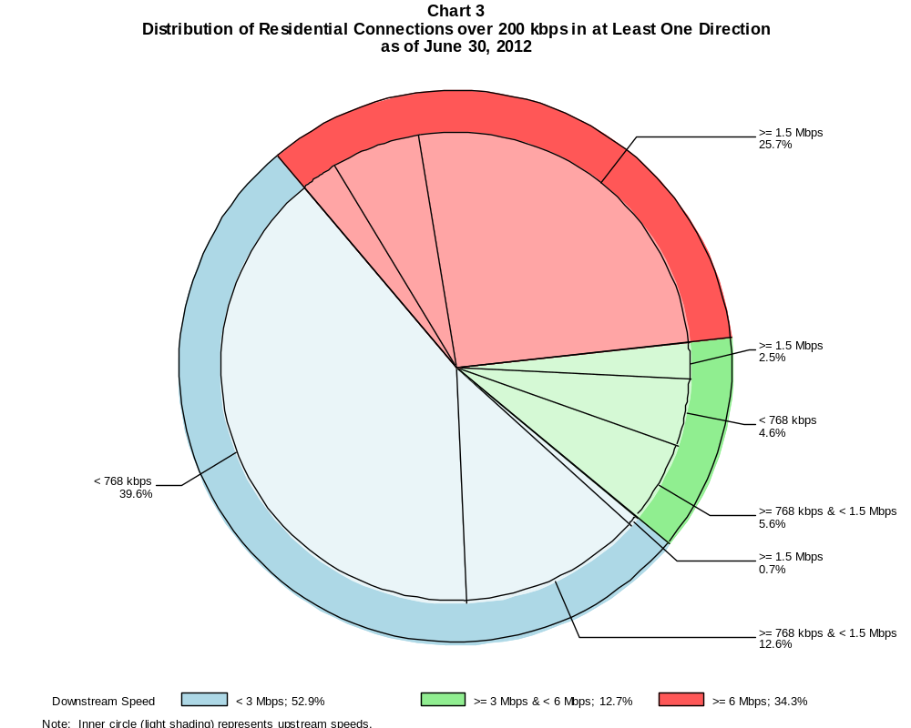

Residential Connections over 200 kbps in at Least One Direction (in thousands)

 | Downstream Speed
Upstream Speed | Less than 3 Mbps | At least 3 Mbps  and less than 6 Mbps | At least 6 Mbps | Total
Less than 768 kbps | 77,854 | 9,025 | 4,945 | 91,825
At least 768 kbps & Less than 1.5 Mbps | 24,864 | 11,074 | 12,004 | 47,942
At least 1.5 Mbps | 1,399 | 4,959 | 50,579 | 56,938
Total | 104,118 | 25,058 | 67,528 | 196,704

Percentages

Less than 768 kbps | 39.6 | 4.6 | 2.5 | 46.7
At least 768 kbps & Less than 1.5 Mbps | 12.6 | 5.6 | 6.1 | 24.4
At least 1.5 Mbps | 0.7 | 2.5 | 25.7 | 28.9
Total | 52.9 | 12.7 | 34.3 | 100.0

Note: Figures may not sum to totals due to rounding.
Source: FCC Form 477, Parts I and VI.

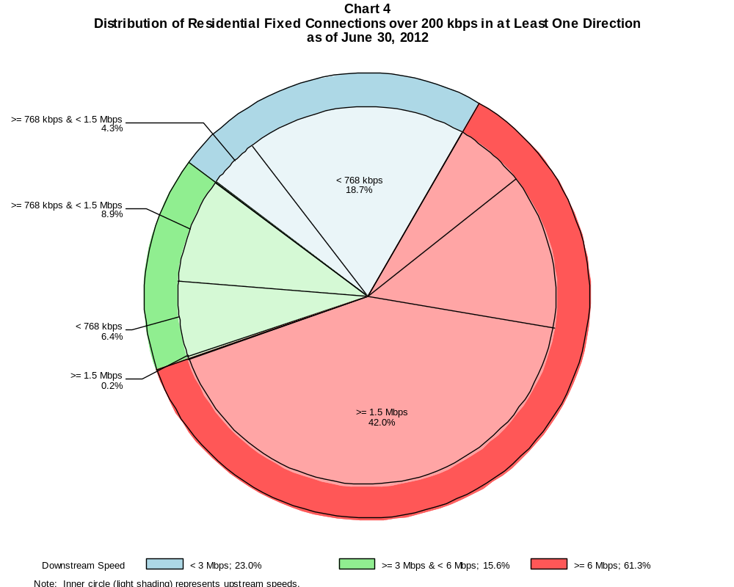

Residential Fixed Connections over 200 kbps in at Least One Direction (in thousands)

 | Downstream Speed
Upstream Speed | Less than 3 Mbps | At least 3 Mbps  and less than 6 Mbps | At least 6 Mbps | Total
Less than 768 kbps | 15,359 | 5,286 | 4,916 | 25,561
At least 768 kbps & Less than 1.5 Mbps | 3,521 | 7,357 | 10,981 | 21,860
At least 1.5 Mbps | 74 | 191 | 34,546 | 34,812
Total | 18,954 | 12,835 | 50,443 | 82,233

Percentages

Less than 768 kbps | 18.7 | 6.4 | 6.0 | 31.1
At least 768 kbps & Less than 1.5 Mbps | 4.3 | 8.9 | 13.4 | 26.6
At least 1.5 Mbps | 0.1 | 0.2 | 42.0 | 42.3
Total | 23.0 | 15.6 | 61.3 | 100.0

Note: Figures may not sum to totals due to rounding.
Source: FCC Form 477, Part VI.

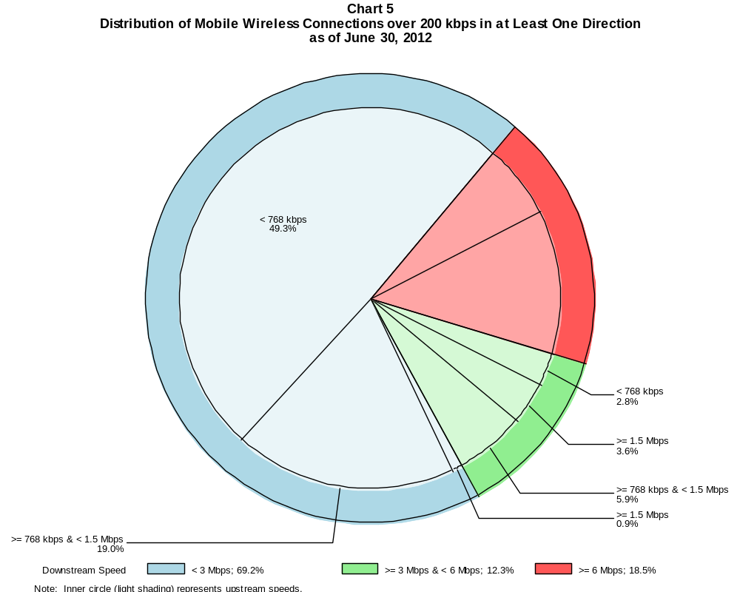

Mobile Wireless Connections over 200 kbps in at Least One Direction (in thousands)

 | Downstream Speed
Upstream Speed | Less than 3 Mbps | At least 3 Mbps  and less than 6 Mbps | At least 6 Mbps | Total
Less than 768 kbps | 75,583 | 4,271 | 34 | 79,887
At least 768 kbps & Less than 1.5 Mbps | 29,115 | 9,120 | 9,629 | 47,864
At least 1.5 Mbps | 1,411 | 5,526 | 18,749 | 25,686
Total | 106,109 | 18,917 | 28,412 | 153,438

Percentages

Less than 768 kbps | 49.3 | 2.8 | 0.0 | 52.1
At least 768 kbps & Less than 1.5 Mbps | 19.0 | 5.9 | 6.3 | 31.2
At least 1.5 Mbps | 0.9 | 3.6 | 12.2 | 16.7
Total | 69.2 | 12.3 | 18.5 | 100.0

Note: Figures may not sum to totals due to rounding.
Source: FCC Form 477, Part I.

Table 5
Connections over 200 kbps in at Least One Direction by Technology 2008-2012
(In thousands)

 | 2008 |  | 2009 |  | 2010 |  | 2011 |  | 2012
Technology | Jun | Dec | Jun | Dec | Jun | Dec | Jun | Dec | Jun
Total | 132,814 | 102,239 | 119,433 | 136,294 | 157,017 | 182,065 | 206,131 | 230,387 | 243,397
Total Fixed | 73,123 | 75,707 | 77,997 | 79,994 | 81,764 | 84,521 | 86,575 | 88,320 | 89,959
aDSL | 29,964 | 30,198 | 30,631 | 30,987 | 30,759 | 31,470 | 31,611 | 31,341 | 31,188
sDSL | 275 | 241 | 217 | 225 | 191 | 167 | 159 | 148 | 140
Other Wireline¹ | 670 | 709 | 689 | 719 | 755 | 795 | 778 | 795 | 769
Cable Modem | 38,190 | 40,251 | 41,434 | 42,439 | 43,923 | 45,334 | 46,698 | 48,257 | 49,663
FTTP² | 2,346 | 2,884 | 3,548 | 3,980 | 4,441 | 4,993 | 5,477 | 5,898 | 6,299
Satellite | 869 | 938 | 990 | 1,116 | 1,144 | 1,176 | 1,204 | 1,190 | 1,217
Fixed Wireless | 808 | 485 | 488 | 527 | 551 | 587 | 649 | 692 | 683
Mobile Wireless³ | 59,691 | 26,532 | 41,436 | 56,300 | 75,253 | 97,544 | 119,556 | 142,066 | 153,438

¹ Power Line and Other are summarized with Other Wireline to maintain firm confidentiality. See Technical Notes at the end of the report for a description of
Form 477 technology categories and other reporting requirements.
² Fiber to the premises.
³ Reporting instructions for mobile wireless changed between the June 2008 and December 2008 data.
Note: Some historical data have been revised. Figures may not sum to totals due to rounding.
Source: FCC Form 477, Part I.

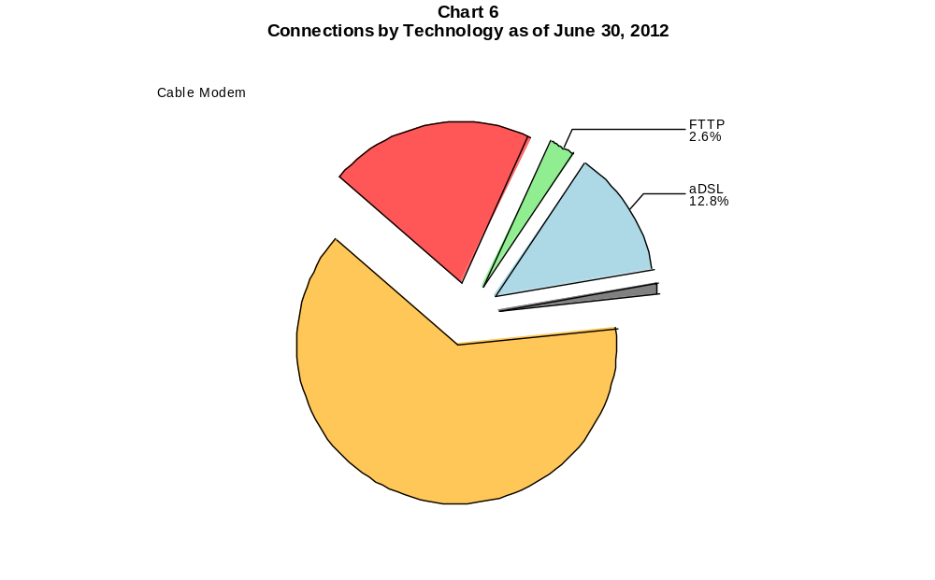

Table 6
Residential Connections over 200 kbps in at Least One Direction by Technology 2008-2012
(In thousands)

 | 2008 |  | 2009 |  | 2010 |  | 2011 |  | 2012
Technology | Jun | Dec | Jun | Dec | Jun | Dec | Jun | Dec | Jun
Total | 79,090 | 88,190 | 103,300 | 117,089 | 132,567 | 149,441 | 171,773 | 186,702 | 196,704
Total Fixed | 67,554 | 69,047 | 71,509 | 73,394 | 75,251 | 76,918 | 78,906 | 80,709 | 82,233
aDSL | 26,950 | 26,488 | 27,047 | 27,402 | 27,488 | 27,467 | 27,754 | 27,767 | 27,650
sDSL | 81 | 74 | 71 | 85 | 65 | 53 | 52 | 54 | 49
Other Wireline¹ | 37 | 47 | 49 | 56 | 61 | 76 | 45 | 40 | 13
Cable Modem | 36,901 | 38,681 | 39,909 | 40,872 | 42,178 | 43,295 | 44,480 | 45,826 | 47,032
FTTP² | 2,139 | 2,717 | 3,348 | 3,758 | 4,185 | 4,704 | 5,118 | 5,521 | 5,892
Satellite | 705 | 630 | 668 | 767 | 787 | 811 | 885 | 886 | 998
Fixed Wireless | 741 | 410 | 417 | 454 | 486 | 513 | 572 | 615 | 598
Mobile Wireless³ | 11,536 | 19,142 | 31,791 | 43,695 | 57,316 | 72,523 | 92,867 | 105,993 | 114,472

¹ Power Line and Other are summarized with Other Wireline to maintain firm confidentiality. See Technical Notes at the end of the report for a description of
Form 477 technology categories and other reporting requirements.
² Fiber to the premises.
³ Reporting instructions for mobile wireless changed between the June 2008 and December 2008 data.
Note: Some historical data have been revised. Figures may not sum to totals due to rounding.
Source: FCC Form 477, Part I.

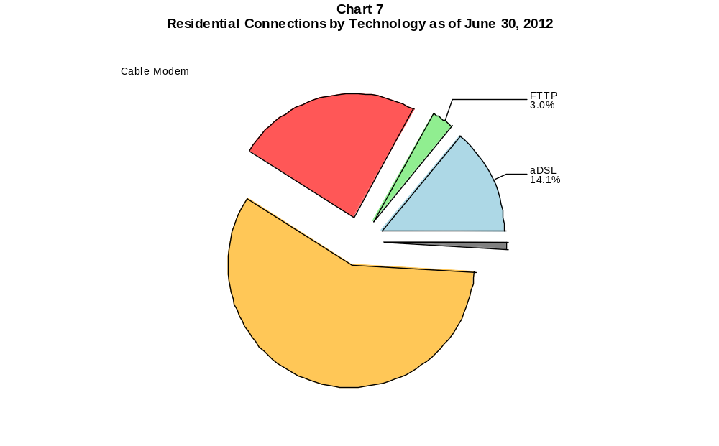

Table 7
Connections at Least 3 Mbps Downstream and 768 kbps Upstream by Technology 2008-2012
(In thousands)

 | 2008 | 2009 |  | 2010 |  | 2011 |  | 2012
Technology | Dec | Jun | Dec | Jun | Dec | Jun | Dec | Jun
Total | 31,120 | 33,332 | 40,669 | 45,552 | 55,110 | 64,819 | 82,013 | 100,271
Total Fixed | 30,987 | 33,108 | 38,963 | 41,364 | 44,694 | 48,577 | 51,095 | 57,247
aDSL | 5,403 | 5,614 | 6,389 | 6,275 | 7,302 | 8,909 | 10,355 | 12,879
sDSL | 5 | 9 | 19 | 13 | 14 | 16 | 26 | 32
Other Wireline¹ | 122 | 129 | 150 | 177 | 211 | 204 | 228 | 239
Cable Modem | 22,708 | 23,958 | 28,583 | 30,616 | 32,338 | 34,113 | 34,693 | 37,798
FTTP² | 2,694 | 3,333 | 3,739 | 4,192 | 4,725 | 5,188 | 5,606 | 6,000
Satellite | # | # | # | # | # | # | # | 87
Fixed Wireless | 54 | 64 | 82 | 92 | 105 | 145 | 186 | 212
Mobile Wireless | 133 | 224 | 1,706 | 4,188 | 10,416 | 16,242 | 30,918 | 43,025

# = Rounds to Zero.
¹ Power Line and Other are summarized with Other Wireline to maintain firm confidentiality. See Technical Notes at the end of the report for a description of
Form 477 technology categories and other reporting requirements.
² Fiber to the premises.
Note: Some historical data have been revised. Figures may not sum to totals due to rounding.
Source: FCC Form 477, Part I.

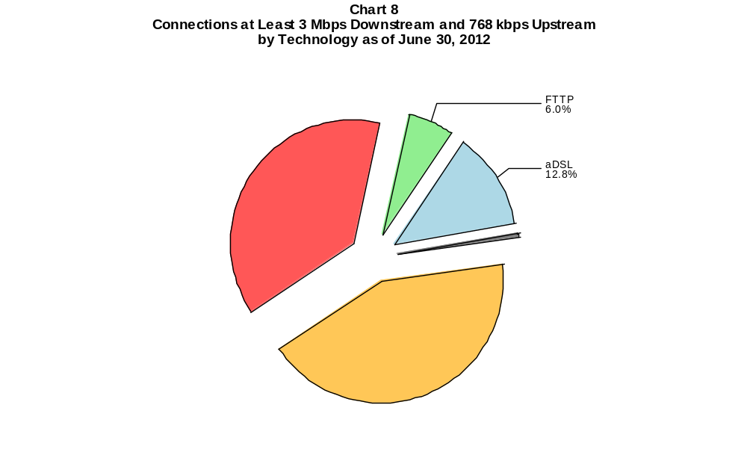

Table 8
Residential Connections at Least 3 Mbps Downstream and 768 kbps Upstream by Technology 2008-2012
(In thousands)

 | 2008 | 2009 |  | 2010 |  | 2011 |  | 2012
Technology | Dec | Jun | Dec | Jun | Dec | Jun | Dec | Jun
Total | 29,127 | 31,356 | 38,426 | 42,243 | 47,632 | 51,783 | 63,734 | 78,616
Total Fixed | 29,013 | 31,161 | 36,844 | 39,037 | 41,769 | 45,263 | 47,425 | 53,077
aDSL | 4,613 | 4,895 | 5,633 | 5,557 | 6,421 | 7,909 | 9,278 | 11,571
sDSL | 1 | 2 | 10 | 2 | 2 | 4 | 12 | 12
Other Wireline¹ | 11 | 12 | 19 | 20 | 36 | 15 | 16 | 7
Cable Modem | 21,776 | 23,025 | 27,548 | 29,398 | 30,742 | 32,321 | 32,687 | 35,583
FTTP² | 2,571 | 3,177 | 3,566 | 3,982 | 4,482 | 4,894 | 5,271 | 5,632
Satellite | 0 | 0 | 0 | 0 | 0 | 0 | # | 86
Fixed Wireless | 42 | 50 | 68 | 77 | 86 | 121 | 161 | 184
Mobile Wireless | 114 | 196 | 1,582 | 3,206 | 5,863 | 6,520 | 16,309 | 25,539

# = Rounds to Zero.
¹ Power Line and Other are summarized with Other Wireline to maintain firm confidentiality. See Technical Notes at the end of the report for a description of
Form 477 technology categories and other reporting requirements.
² Fiber to the premises.
Note: Some historical data have been revised. Figures may not sum to totals due to rounding.
Source: FCC Form 477, Part I.

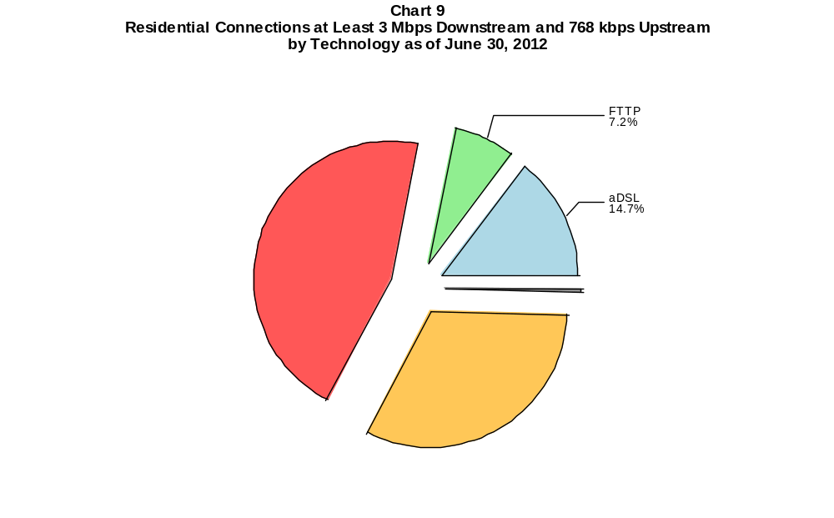

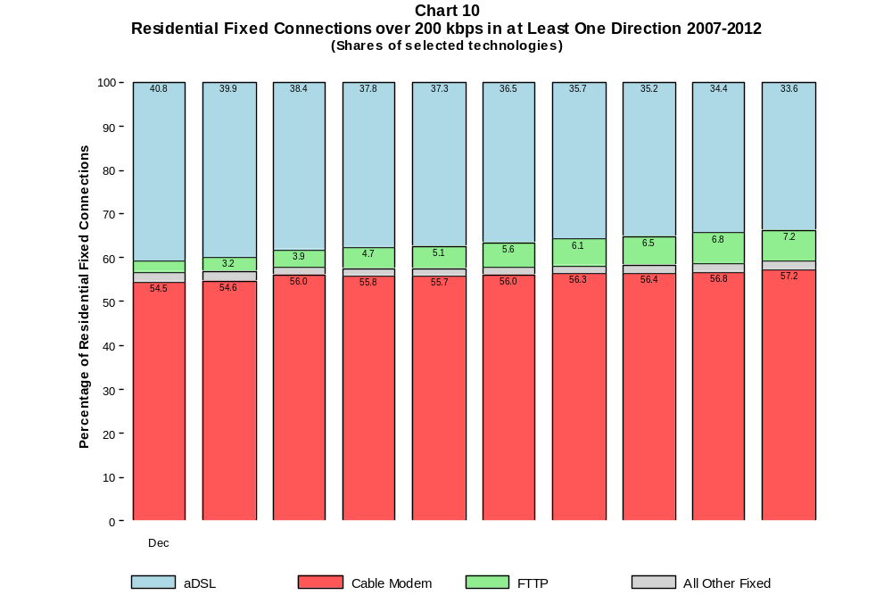

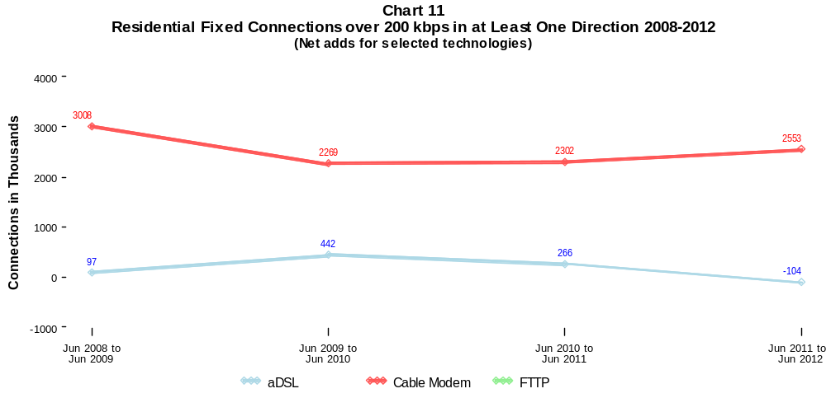

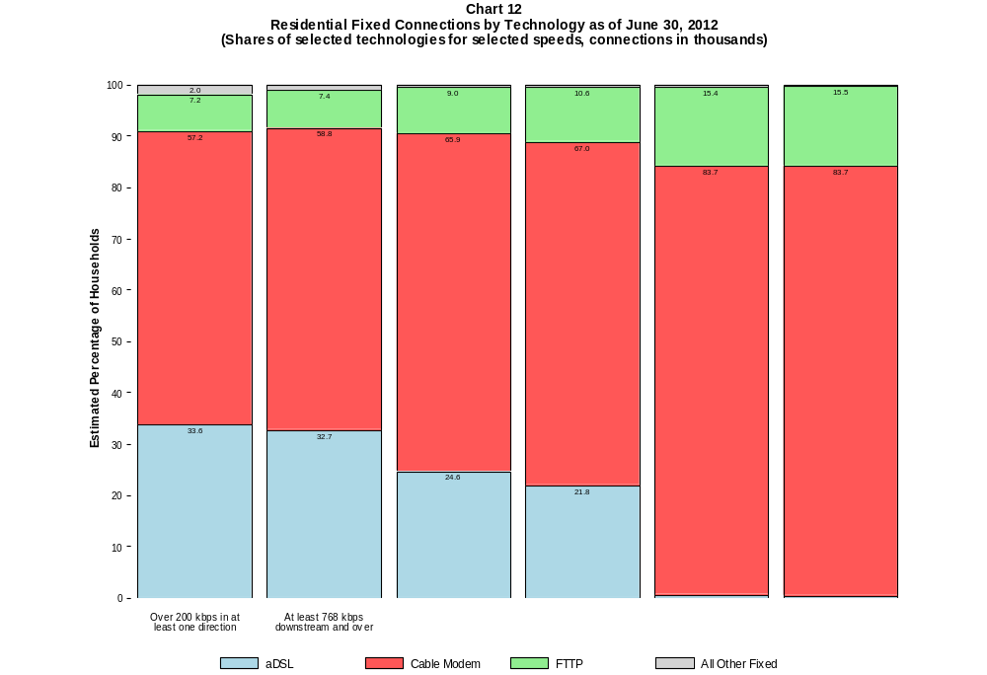

Table 9
Residential Connections by Technology and Speed (BTOP/BIP Definition)
as of June 30, 2012
(In thousands)

Technology | At Most  200 kbps  Upstream or  less than  768 kbps  Downstream | Over  200 kbps  Upstream and  at least  768 kbps  Downstream | Total
aDSL | 1,803 | 25,847 | 27,650
sDSL | 13 | 36 | 49
Other Wireline | # | 13 | 13
Cable Modem | 472 | 46,560 | 47,032
FTTP | 14 | 5,878 | 5,892
Satellite | 709 | 289 | 998
Fixed Wireless | 90 | 507 | 598
Mobile Wireless | 37,649 | 76,823 | 114,472
Total | 40,751 | 155,953 | 196,704

# = Rounds to Zero. Power Line and Other are combined with Other Wireline to maintain firm confidentiality.
Note: Figures may not sum to totals due to rounding.
Source: FCC Form 477, Parts I and VI.

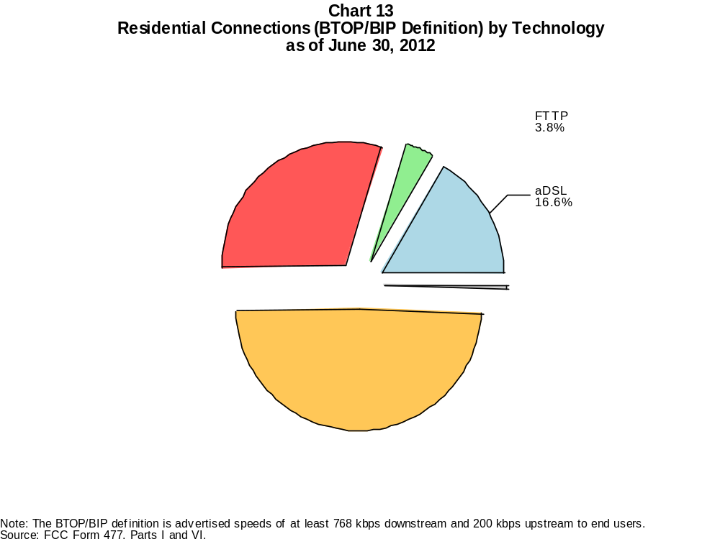

Table 10
Connections by Downstream Speed Tier and Technology as of June 30, 2012
(In thousands)

 | Downstream Speed
Technology | Greater than 200  kbps and less than  768 kbps | At least 768 kbps  and less than  1.5 Mbps | At least 1.5 Mbps  and less than  3 Mbps | At least 3 Mbps  and less than  6 Mbps | At least 6 Mbps  and less than  10 Mbps | At least 10 Mbps  and less than  25 Mbps | At least 25 Mbps  and less than  100 Mbps | At least 100 Mbps | Total
aDSL | 1,666 | 4,391 | 7,452 | 10,192 | 4,855 | 2,525 | 105 | # | 31,188
sDSL | 37 | 43 | 28 | * | * | 16 | * | # | 140
Other Wireline | 43 | 40 | 448 | 102 | 24 | 44 | 41 | 27 | 769
Cable Modem | 145 | 1,321 | 3,983 | 4,200 | 5,158 | 27,819 | 6,968 | 69 | 49,663
FTTP | 17 | 78 | 112 | 234 | 160 | 4,377 | 1,262 | 59 | 6,299
Satellite | 328 | 537 | 258 | * | * | * | 0 | 0 | 1,217
Fixed Wireless | 85 | 167 | 195 | 174 | 42 | 18 | 2 | 1 | 683
Mobile Wireless | 43,714 | 7,568 | 54,826 | 18,917 | 24,767 | * | * | 0 | 153,438
Total | 46,034 | 14,145 | 67,302 | 33,848 | 35,010 | 34,911 | 11,990 | 156 | 243,397

Percentages

aDSL | 0.7 | 1.8 | 3.1 | 4.2 | 2.0 | 1.0 | 0.0 | 0.0 | 12.8
sDSL | 0.0 | 0.0 | 0.0 | * | * | 0.0 | * | 0.0 | 0.1
Other Wireline | 0.0 | 0.0 | 0.2 | 0.0 | 0.0 | 0.0 | 0.0 | 0.0 | 0.3
Cable Modem | 0.1 | 0.5 | 1.6 | 1.7 | 2.1 | 11.4 | 2.9 | 0.0 | 20.4
FTTP | 0.0 | 0.0 | 0.0 | 0.1 | 0.1 | 1.8 | 0.5 | 0.0 | 2.6
Satellite | 0.1 | 0.2 | 0.1 | * | * | * | 0.0 | 0.0 | 0.5
Fixed Wireless | 0.0 | 0.1 | 0.1 | 0.1 | 0.0 | 0.0 | 0.0 | 0.0 | 0.3
Mobile Wireless | 18.0 | 3.1 | 22.5 | 7.8 | 10.2 | * | * | 0.0 | 63.0
Total | 18.9 | 5.8 | 27.7 | 13.9 | 14.4 | 14.3 | 4.9 | 0.1 | 100.0

# = Rounds to Zero. Power Line and Other are combined with Other Wireline to maintain firm confidentiality.
* = Data withheld to maintain firm confidentiality.
Note: Figures may not sum to totals due to rounding.
Source: FCC Form 477, Part I.

Table 11
Residential Connections by Downstream Speed Tier and Technology as of June 30, 2012
(In thousands)

 | Downstream Speed
Technology | Greater than 200  kbps and less than  768 kbps | At least 768 kbps  and less than  1.5 Mbps | At least 1.5 Mbps  and less than  3 Mbps | At least 3 Mbps  and less than  6 Mbps | At least 6 Mbps  and less than  10 Mbps | At least 10 Mbps  and less than  25 Mbps | At least 25 Mbps  and less than  100 Mbps | At least 100 Mbps | Total
aDSL | 1,546 | 4,027 | 6,536 | 8,639 | 4,486 | 2,319 | 98 | # | 27,650
sDSL | 13 | 20 | 4 | * | * | 9 | * | 0 | 49
Other Wireline | # | 4 | 2 | 1 | 1 | 3 | 0 | 1 | 13
Cable Modem | 130 | 1,299 | 3,900 | 3,822 | 4,815 | 26,285 | 6,730 | 52 | 47,032
FTTP | 13 | 70 | 90 | 206 | 147 | 4,170 | 1,176 | 20 | 5,892
Satellite | 194 | 494 | 220 | * | * | * | 0 | 0 | 998
Fixed Wireless | 75 | 145 | 172 | 154 | 37 | 14 | 1 | # | 598
Mobile Wireless | 35,216 | 6,839 | 43,109 | 12,223 | 13,737 | * | * | 0 | 114,472
Total | 37,188 | 12,897 | 54,033 | 25,058 | 23,224 | 32,907 | 11,324 | 74 | 196,704

Percentages

aDSL | 0.8 | 2.0 | 3.3 | 4.4 | 2.3 | 1.2 | 0.0 | 0.0 | 14.1
sDSL | 0.0 | 0.0 | 0.0 | * | * | 0.0 | * | 0.0 | 0.0
Other Wireline | 0.0 | 0.0 | 0.0 | 0.0 | 0.0 | 0.0 | 0.0 | 0.0 | 0.0
Cable Modem | 0.1 | 0.7 | 2.0 | 1.9 | 2.4 | 13.4 | 3.4 | 0.0 | 23.9
FTTP | 0.0 | 0.0 | 0.0 | 0.1 | 0.1 | 2.1 | 0.6 | 0.0 | 3.0
Satellite | 0.1 | 0.3 | 0.1 | * | * | * | 0.0 | 0.0 | 0.5
Fixed Wireless | 0.0 | 0.1 | 0.1 | 0.1 | 0.0 | 0.0 | 0.0 | 0.0 | 0.3
Mobile Wireless | 17.9 | 3.5 | 21.9 | 6.2 | 7.0 | * | * | 0.0 | 58.2
Total | 18.9 | 6.6 | 27.5 | 12.7 | 11.8 | 16.7 | 5.8 | 0.0 | 100.0

# = Rounds to Zero. Power Line and Other are combined with Other Wireline to maintain firm confidentiality.
* = Data withheld to maintain firm confidentiality.
Note: Figures may not sum to totals due to rounding.
Source: FCC Form 477, Part I.

Table 12
Nationwide Number of Providers of Connections over 200 kbps in at Least One Direction
by Technology 2008-2012

 | 2008 |  | 2009 |  | 2010 |  | 2011 |  | 2012
Technology | Jun | Dec | Jun | Dec | Jun | Dec | Jun | Dec | Jun
aDSL | 863 | 881 | 876 | 862 | 875 | 865 | 867 | 868 | 860
sDSL | 238 | 264 | 257 | 261 | 251 | 247 | 252 | 255 | 249
Other Wireline | 259 | 292 | 283 | 274 | 267 | 270 | 265 | 274 | 258
Cable Modem | 296 | 342 | 351 | 345 | 345 | 357 | 400 | 404 | 399
FTTP | 308 | 432 | 462 | 485 | 510 | 545 | 579 | 621 | 642
Satellite | 4 | 5 | 4 | 4 | 4 | 4 | 5 | 6 | 5
Fixed Wireless | 505 | 620 | 621 | 607 | 625 | 646 | 672 | 711 | 707
Mobile Wireless | 24 | 47 | 48 | 51 | 55 | 57 | 64 | 69 | 68
Power Line and Other | 6 | 5 | 6 | 6 | 5 | 7 | 4 | 5 | *
Total | 1,395 | 1,562 | 1,551 | 1,526 | 1,536 | 1,566 | 1,624 | 1,683 | 1,662

Note: Some historical data have been revised. Multiple Form 477 filers within a holding company structure count as one provider. * = 1-3 providers.
Source: FCC Form 477, Part I.

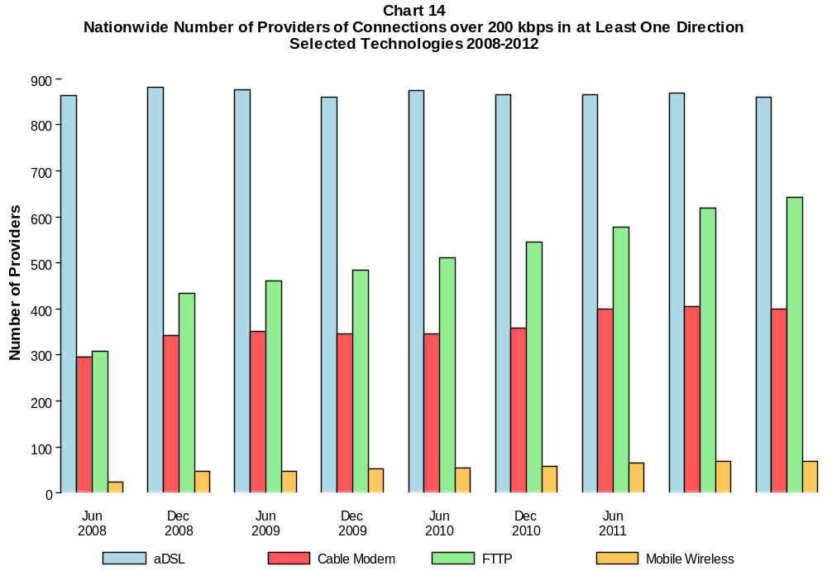

Table 13
Residential Fixed Connections (Approximating the National Broadband Availability Target)
and Households by State as of June 30, 2012
(Connections with advertised speeds at least 3 Mbps down and 768 up and households, in thousands)
State | Connections | Households | Subscribership  Ratio
Alabama | 564 | 1,902 | 0.30
Alaska | 88 | 260 | 0.34
American Samoa | 0 | 11 | 0.00
Arizona | 1,330 | 2,440 | 0.54
Arkansas | 294 | 1,159 | 0.25
California | 5,609 | 12,712 | 0.44
Colorado | 1,217 | 2,005 | 0.61
Connecticut | 799 | 1,372 | 0.58
Delaware | 240 | 347 | 0.69
District of Columbia | 175 | 268 | 0.65
Florida | 3,830 | 7,463 | 0.51
Georgia | 1,542 | 3,648 | 0.42
Guam | * | 51 | *
Hawaii | * | 456 | *
Idaho | 180 | 593 | 0.30
Illinois | 2,150 | 4,861 | 0.44
Indiana | 1,042 | 2,516 | 0.41
Iowa | 302 | 1,231 | 0.25
Kansas | 366 | 1,121 | 0.33
Kentucky | 658 | 1,732 | 0.38
Louisiana | 535 | 1,756 | 0.30
Maine | 147 | 556 | 0.26
Maryland | 1,503 | 2,156 | 0.70
Massachusetts | 1,914 | 2,549 | 0.75
Michigan | 1,775 | 3,848 | 0.46
Minnesota | 1,017 | 2,097 | 0.48
Mississippi | 237 | 1,120 | 0.21
Missouri | 693 | 2,390 | 0.29
Montana | 157 | 415 | 0.38
Nebraska | 328 | 727 | 0.45
Nevada | 511 | 1,027 | 0.50
New Hampshire | 339 | 519 | 0.65
New Jersey | 2,436 | 3,215 | 0.76
New Mexico | 302 | 806 | 0.37
New York | 3,939 | 7,345 | 0.54
North Carolina | 668 | 3,818 | 0.17
North Dakota | 117 | 283 | 0.41
Northern Mariana Isl | * | 21 | *
Ohio | 1,154 | 4,597 | 0.25
Oklahoma | 416 | 1,476 | 0.28
Oregon | 854 | 1,539 | 0.55
Pennsylvania | 2,896 | 5,025 | 0.58
Puerto Rico | 114 | 1,230 | 0.09
Rhode Island | * | 410 | *
South Carolina | 534 | 1,831 | 0.29
South Dakota | 153 | 326 | 0.47
Tennessee | 996 | 2,522 | 0.39
Texas | 3,024 | 9,113 | 0.33
Utah | 508 | 903 | 0.56
Vermont | 156 | 256 | 0.61
Virgin Islands | * | 56 | *
Virginia | 1,855 | 3,079 | 0.60
Washington | 1,608 | 2,657 | 0.61
West Virginia | 373 | 766 | 0.49
Wisconsin | 682 | 2,289 | 0.30
Wyoming | 102 | 231 | 0.44
Total | 53,077 | 119,103 | 0.45

# = Rounds to Zero; * = Data withheld to maintain firm confidentiality.
Note: Figures may not sum to totals due to rounding.
Sources: FCC Form 477, Part VI (Connections); Geolytics 2011 Block-Level Estimates (Households for U.S. and District of Columbia);
Census 2010 (Housing Units for Puerto Rico, American Samoa, Guam, Northern Mariana Islands and U.S. Virgin Islands).

Table 14
Residential Fixed Connections and Households by State as of June 30, 2012
(Connections over 200 kbps in at least one direction and households, in thousands)

State | Connections | Households | Subscribership  Ratio
Alabama | 1,091 | 1,902 | 0.57
Alaska | 185 | 260 | 0.71
American Samoa | * | 11 | *
Arizona | 1,692 | 2,440 | 0.69
Arkansas | 625 | 1,159 | 0.54
California | 9,634 | 12,712 | 0.76
Colorado | 1,517 | 2,005 | 0.76
Connecticut | 1,078 | 1,372 | 0.79
Delaware | 271 | 347 | 0.78
District of Columbia | 194 | 268 | 0.72
Florida | 5,492 | 7,463 | 0.74
Georgia | 2,385 | 3,648 | 0.65
Guam | * | 51 | *
Hawaii | * | 456 | *
Idaho | 364 | 593 | 0.61
Illinois | 3,268 | 4,861 | 0.67
Indiana | 1,601 | 2,516 | 0.64
Iowa | 808 | 1,231 | 0.66
Kansas | 751 | 1,121 | 0.67
Kentucky | 1,079 | 1,732 | 0.62
Louisiana | 1,045 | 1,756 | 0.60
Maine | 417 | 556 | 0.75
Maryland | 1,638 | 2,156 | 0.76
Massachusetts | 2,056 | 2,549 | 0.81
Michigan | 2,503 | 3,848 | 0.65
Minnesota | 1,452 | 2,097 | 0.69
Mississippi | 558 | 1,120 | 0.50
Missouri | 1,472 | 2,390 | 0.62
Montana | 264 | 415 | 0.64
Nebraska | 493 | 727 | 0.68
Nevada | 681 | 1,027 | 0.66
New Hampshire | 421 | 519 | 0.81
New Jersey | 2,623 | 3,215 | 0.82
New Mexico | 473 | 806 | 0.59
New York | 5,553 | 7,345 | 0.76
North Carolina | 2,637 | 3,818 | 0.69
North Dakota | 197 | 283 | 0.70
Northern Mariana Isl | * | 21 | *
Ohio | 3,118 | 4,597 | 0.68
Oklahoma | 853 | 1,476 | 0.58
Oregon | 1,064 | 1,539 | 0.69
Pennsylvania | 3,591 | 5,025 | 0.71
Puerto Rico | 521 | 1,230 | 0.42
Rhode Island | 311 | 410 | 0.76
South Carolina | 1,164 | 1,831 | 0.64
South Dakota | 219 | 326 | 0.67
Tennessee | 1,465 | 2,522 | 0.58
Texas | 5,916 | 9,113 | 0.65
Utah | 658 | 903 | 0.73
Vermont | 196 | 256 | 0.77
Virgin Islands | 16 | 56 | 0.29
Virginia | 2,156 | 3,079 | 0.70
Washington | 1,919 | 2,657 | 0.72
West Virginia | 459 | 766 | 0.60
Wisconsin | 1,534 | 2,289 | 0.67
Wyoming | 152 | 231 | 0.66
Total | 82,233 | 119,103 | 0.69

# = Rounds to Zero; * = Data withheld to maintain firm confidentiality.
Note: Figures may not sum to totals due to rounding.
Sources: FCC Form 477, Part VI (Connections); Geolytics 2011 Block-Level Estimates (Households for U.S. and District of Columbia);
Census 2010 (Housing Units for Puerto Rico, American Samoa, Guam, Northern Mariana Islands and U.S. Virgin Islands).

Table 15
Connections by Type of End User by State as of June 30, 2012
(Connections over 200 kbps in at least one direction, in thousands)

 | Connections |  | Percentages
State | Residential | Business | Residential | Business | Total
Alabama | 2,706 | 407 | 86.9 | 13.1 | 3,113
Alaska | 506 | 78 | 86.7 | 13.3 | 584
American Samoa | * | * | * | * | *
Arizona | 3,881 | 713 | 84.5 | 15.5 | 4,594
Arkansas | 1,703 | 253 | 87.0 | 13.0 | 1,956
California | 25,044 | 5,730 | 81.4 | 18.6 | 30,773
Colorado | 3,498 | 853 | 80.4 | 19.6 | 4,352
Connecticut | 2,455 | 557 | 81.5 | 18.5 | 3,012
Delaware | 603 | 134 | 81.9 | 18.1 | 737
District of Columbia | 557 | 655 | 46.0 | 54.0 | 1,211
Florida | 12,638 | 3,213 | 79.7 | 20.3 | 15,851
Georgia | 6,082 | 1,488 | 80.3 | 19.7 | 7,571
Guam | 58 | 14 | 80.0 | 20.0 | 72
Hawaii | 964 | 175 | 84.7 | 15.3 | 1,139
Idaho | 870 | 198 | 81.5 | 18.5 | 1,068
Illinois | 7,983 | 2,101 | 79.2 | 20.8 | 10,085
Indiana | 3,660 | 667 | 84.6 | 15.4 | 4,326
Iowa | 1,588 | 307 | 83.8 | 16.2 | 1,895
Kansas | 1,660 | 628 | 72.5 | 27.5 | 2,289
Kentucky | 2,475 | 494 | 83.4 | 16.6 | 2,969
Louisiana | 2,902 | 510 | 85.1 | 14.9 | 3,412
Maine | 748 | 111 | 87.1 | 12.9 | 859
Maryland | 3,986 | 902 | 81.6 | 18.4 | 4,887
Massachusetts | 4,503 | 1,010 | 81.7 | 18.3 | 5,512
Michigan | 5,478 | 1,813 | 75.1 | 24.9 | 7,291
Minnesota | 3,200 | 911 | 77.8 | 22.2 | 4,111
Mississippi | 1,696 | 219 | 88.6 | 11.4 | 1,915
Missouri | 3,431 | 969 | 78.0 | 22.0 | 4,400
Montana | 594 | 88 | 87.1 | 12.9 | 682
Nebraska | 1,038 | 251 | 80.5 | 19.5 | 1,289
Nevada | 1,821 | 404 | 81.8 | 18.2 | 2,225
New Hampshire | 834 | 149 | 84.8 | 15.2 | 983
New Jersey | 6,244 | 1,379 | 81.9 | 18.1 | 7,623
New Mexico | 1,134 | 188 | 85.8 | 14.2 | 1,322
New York | 13,128 | 3,054 | 81.1 | 18.9 | 16,182
North Carolina | 5,709 | 1,375 | 80.6 | 19.4 | 7,085
North Dakota | 453 | 83 | 84.6 | 15.4 | 536
Northern Mariana Isl | * | * | * | * | *
Ohio | 6,881 | 1,737 | 79.8 | 20.2 | 8,618
Oklahoma | 2,253 | 381 | 85.5 | 14.5 | 2,634
Oregon | 2,447 | 528 | 82.3 | 17.7 | 2,975
Pennsylvania | 7,930 | 1,652 | 82.8 | 17.2 | 9,581
Puerto Rico | 1,628 | 201 | 89.0 | 11.0 | 1,829
Rhode Island | 659 | 151 | 81.4 | 18.6 | 809
South Carolina | 2,393 | 445 | 84.3 | 15.7 | 2,838
South Dakota | 494 | 67 | 88.0 | 12.0 | 561
Tennessee | 3,666 | 860 | 81.0 | 19.0 | 4,526
Texas | 16,676 | 4,612 | 78.3 | 21.7 | 21,288
Utah | 1,571 | 421 | 78.8 | 21.2 | 1,992
Vermont | 371 | 67 | 84.8 | 15.2 | 438
Virgin Islands | 59 | 18 | 76.2 | 23.8 | 78
Virginia | 5,136 | 1,357 | 79.1 | 20.9 | 6,493
Washington | 4,404 | 1,166 | 79.1 | 20.9 | 5,570
West Virginia | 968 | 142 | 87.2 | 12.8 | 1,110
Wisconsin | 2,975 | 749 | 79.9 | 20.1 | 3,724
Wyoming | 354 | 55 | 86.6 | 13.4 | 408
Total | 196,704 | 46,693 | 80.8 | 19.2 | 243,397

# = Rounds to Zero.
* = Data withheld to maintain firm confidentiality.
Figures may not sum to totals due to rounding.
Source: FCC Form 477, Part I and VI.

Table 16
Connections by Technology by State as of June 30, 2012
(Connections over 200 kbps in at least one direction, in thousands)

State | ADSL | SDSL | Other  Wireline | Cable  Modem | Fiber | Satellite | Fixed  Wireless | Mobile  Wireless | Total
Alabama | 546 | 4 | * | 592 | 9 | * | 4 | 1,911 | 3,113
Alaska | 78 | 2 | 0 | * | 1 | * | 4 | 369 | 584
American Samoa | * | * | 0 | * | * | 0 | * | 0 | *
Arizona | 600 | 1 | * | 1,156 | 4 | * | 25 | 2,772 | 4,594
Arkansas | 344 | # | * | 308 | 6 | * | 2 | 1,265 | 1,956
California | 4,370 | 13 | * | 5,222 | 710 | * | 29 | 20,228 | 30,773
Colorado | * | 2 | 0 | 870 | 6 | * | 45 | 2,690 | 4,352
Connecticut | * | 1 | 0 | 744 | 4 | * | * | 1,836 | 3,012
Delaware | * | # | 0 | * | * | * | 0 | 445 | 737
District of Columbia | * | 2 | 0 | * | 14 | * | * | 988 | 1,211
Florida | 1,955 | 1 | * | 3,557 | 395 | * | 5 | 9,846 | 15,851
Georgia | 1,291 | 1 | * | 1,245 | 28 | * | 1 | 4,938 | 7,571
Guam | * | * | * | * | * | 0 | * | * | 72
Hawaii | * | * | 0 | * | 2 | * | * | 742 | 1,139
Idaho | 201 | # | * | 160 | 3 | * | 23 | 667 | 1,068
Illinois | 1,519 | 7 | * | 1,936 | 16 | * | 36 | 6,504 | 10,085
Indiana | 760 | 2 | * | 835 | 69 | * | 31 | 2,591 | 4,326
Iowa | 393 | 2 | * | 403 | 41 | * | 24 | 1,009 | 1,895
Kansas | 275 | 1 | * | 455 | 47 | * | 27 | 1,463 | 2,289
Kentucky | 502 | 3 | * | 614 | 17 | * | 7 | 1,793 | 2,969
Louisiana | 444 | 2 | * | 625 | 39 | * | 5 | 2,256 | 3,412
Maine | 139 | 4 | 0 | 300 | 5 | * | * | 400 | 859
Maryland | * | 2 | 0 | 842 | * | * | 1 | 3,122 | 4,887
Massachusetts | * | 2 | 0 | 1,454 | * | * | 2 | 3,282 | 5,512
Michigan | 909 | 6 | * | 1,687 | 9 | * | 29 | 4,572 | 7,291
Minnesota | 627 | 19 | * | 846 | 39 | * | 20 | 2,525 | 4,111
Mississippi | 309 | 1 | * | 270 | 2 | * | # | 1,294 | 1,915
Missouri | 864 | 1 | * | 653 | 15 | * | 22 | 2,782 | 4,400
Montana | 123 | 1 | 0 | * | 7 | * | 12 | * | 682
Nebraska | 175 | # | * | 331 | 10 | * | 16 | 746 | 1,289

Table 16 - Continued
Connections by Technology by State as of June 30, 2012
(Connections over 200 kbps in at least one direction, in thousands)

State | ADSL | SDSL | Other  Wireline | Cable  Modem | Fiber | Satellite | Fixed  Wireless | Mobile  Wireless | Total
Nevada | 255 | # | 0 | * | 3 | * | 3 | 1,483 | 2,225
New Hampshire | 89 | 1 | * | 354 | 13 | * | # | 516 | 983
New Jersey | 387 | 1 | 0 | 1,830 | * | * | * | 4,731 | 7,623
New Mexico | 285 | # | * | 198 | 4 | * | 16 | 804 | 1,322
New York | 841 | 7 | 0 | 4,253 | * | * | 2 | 10,064 | 16,182
North Carolina | 1,059 | 1 | * | 1,729 | 28 | * | 2 | 4,216 | 7,085
North Dakota | 72 | 1 | * | 111 | 31 | * | 6 | 311 | 536
Northern Mariana Isl | * | 0 | * | * | * | 0 | * | * | *
Ohio | 1,175 | 4 | * | 2,057 | 47 | * | 27 | 5,255 | 8,618
Oklahoma | 391 | # | * | 490 | 14 | * | 13 | 1,688 | 2,634
Oregon | 372 | 4 | * | 683 | 64 | * | 15 | 1,812 | 2,975
Pennsylvania | 1,063 | 4 | 0 | 2,200 | * | * | 1 | 5,687 | 9,581
Puerto Rico | * | 0 | 0 | * | * | * | * | 1,264 | 1,829
Rhode Island | * | # | 0 | * | * | * | * | 470 | 809
South Carolina | 477 | * | 0 | 730 | 34 | * | * | 1,566 | 2,838
South Dakota | 65 | * | 0 | 141 | 22 | * | 12 | * | 561
Tennessee | 603 | # | * | 881 | 72 | * | 4 | 2,911 | 4,526
Texas | 2,967 | 5 | * | 2,804 | 430 | * | 82 | 14,803 | 21,288
Utah | 314 | 1 | * | 325 | 22 | * | 44 | 1,275 | 1,992
Vermont | 97 | * | 0 | 109 | 5 | * | 1 | 216 | 438
Virgin Islands | * | 0 | * | * | 0 | * | * | * | 78
Virginia | 471 | 1 | 0 | 1,187 | * | * | 5 | 4,154 | 6,493
Washington | 597 | 3 | * | 1,362 | 65 | * | 10 | 3,483 | 5,570
West Virginia | * | * | 0 | 297 | 1 | * | 2 | 614 | 1,110
Wisconsin | 651 | 19 | * | 914 | 22 | * | 32 | 2,053 | 3,724
Wyoming | 62 | 2 | * | 89 | 2 | * | 11 | 236 | 408
Total | 31,188 | 140 | 769 | 49,663 | 6,299 | 1,217 | 683 | 153,438 | 243,397

# = Rounds to Zero. Power Line and Other are summarized with Other Wireline to maintain firm confidentiality.
* = Data withheld to maintain firm confidentiality.
Figures may not sum to totals due to rounding.
Source: FCC Form 477, Part I.

Table 17
Connections by Technology by State as of June 30, 2012
(Connections at least 3 Mbps downstream and 768 kbps upstream, in thousands)

State | ADSL | SDSL | Other  Wireline | Cable  Modem | Fiber | Satellite | Fixed  Wireless | Mobile  Wireless | Total
Alabama | 140 | # | 3 | 454 | 5 | * | # | * | 924
Alaska | 28 | * | 1 | * | 1 | * | * | * | 125
American Samoa | 0 | * | 0 | 0 | * | 0 | * | 0 | *
Arizona | 378 | * | 6 | 0 | 3 | * | 7 | * | 1,907
Arkansas | 99 | * | 2 | 210 | 4 | * | * | * | 409
California | 1,576 | 2 | 25 | 3,667 | 691 | * | 15 | * | 10,530
Colorado | * | * | 8 | 858 | 3 | * | 28 | 687 | 1,994
Connecticut | * | * | 2 | 729 | 4 | * | 0 | * | 1,222
Delaware | * | 0 | 1 | * | * | * | 0 | * | 367
District of Columbia | * | * | 3 | * | * | * | * | * | 635
Florida | 710 | # | 18 | 2,979 | * | * | 2 | 2,595 | 6,689
Georgia | 450 | # | * | 1,158 | 20 | * | # | 2,063 | 3,702
Guam | * | * | * | * | * | 0 | * | * | 7
Hawaii | * | * | # | * | 2 | * | * | * | 583
Idaho | 121 | * | 1 | 73 | 2 | * | 5 | * | 387
Illinois | 526 | 3 | * | 1,751 | 13 | * | 6 | 2,971 | 5,283
Indiana | 331 | # | 2 | 715 | 62 | * | 7 | * | 1,632
Iowa | 176 | # | 1 | 131 | 26 | * | 7 | * | 483
Kansas | 78 | # | * | 280 | 27 | * | 2 | 537 | 928
Kentucky | 208 | * | 1 | 476 | 9 | * | 3 | 374 | 1,073
Louisiana | 79 | * | 2 | 452 | 27 | * | 1 | * | 722
Maine | 81 | 1 | # | 87 | 5 | * | * | * | 219
Maryland | * | # | 6 | 821 | * | * | # | * | 2,390
Massachusetts | * | # | 9 | 1,428 | * | * | 1 | 722 | 2,783
Michigan | 336 | 2 | 4 | 1,514 | 8 | * | 7 | * | 3,266
Minnesota | 306 | 12 | * | 744 | 26 | * | 2 | 831 | 1,929
Mississippi | 50 | * | 1 | 203 | 1 | * | * | * | 327
Missouri | 283 | # | * | 438 | 8 | * | 2 | 1,345 | 2,087
Montana | 39 | # | 1 | * | 5 | * | 1 | 0 | 174
Nebraska | 103 | * | 1 | 241 | 6 | * | 1 | * | 460

Table 17 - Continued
Connections by Technology by State as of June 30, 2012
(Connections at least 3 Mbps downstream and 768 kbps upstream, in thousands)

State | ADSL | SDSL | Other  Wireline | Cable  Modem | Fiber | Satellite | Fixed  Wireless | Mobile  Wireless | Total
Nevada | 102 | * | 2 | * | 3 | * | 3 | 696 | 1,231
New Hampshire | 48 | # | 1 | 309 | 13 | * | * | * | 463
New Jersey | 227 | * | 11 | 1,796 | * | * | * | * | 3,614
New Mexico | 140 | # | 2 | 180 | 3 | * | 1 | * | 468
New York | 567 | 1 | 21 | 2,876 | * | * | 1 | * | 6,938
North Carolina | 404 | # | * | 321 | 22 | * | # | 1,184 | 1,940
North Dakota | 26 | # | 1 | 89 | 15 | * | 2 | * | 180
Northern Mariana Isl | * | 0 | 0 | 0 | * | 0 | * | 0 | *
Ohio | 583 | * | 5 | 651 | 43 | * | 4 | 1,486 | 2,773
Oklahoma | 101 | # | * | 326 | 9 | * | 5 | 210 | 654
Oregon | 186 | 1 | 2 | 662 | 61 | * | 8 | * | 1,374
Pennsylvania | 621 | * | 9 | 1,932 | * | * | # | * | 4,487
Puerto Rico | * | 0 | * | * | * | * | * | * | 242
Rhode Island | * | * | 1 | * | * | * | * | * | 446
South Carolina | 159 | * | 4 | 389 | 27 | * | * | 334 | 915
South Dakota | 27 | 0 | # | 126 | 14 | * | 2 | * | 216
Tennessee | 161 | # | 5 | 842 | 55 | * | # | * | 1,767
Texas | 1,074 | # | * | 1,723 | 390 | * | 42 | 7,492 | 10,751
Utah | 173 | # | 3 | 313 | 22 | * | 34 | * | 924
Vermont | 64 | * | # | 104 | 5 | * | * | * | 190
Virgin Islands | 0 | 0 | * | * | 0 | 0 | * | 0 | *
Virginia | 261 | # | 8 | 1,119 | * | * | 2 | * | 3,020
Washington | 329 | * | 8 | 1,322 | 60 | * | 3 | * | 2,635
West Virginia | * | 0 | # | 245 | 1 | * | 2 | * | 428
Wisconsin | 232 | 2 | * | 484 | 15 | * | 2 | 484 | 1,225
Wyoming | 23 | * | # | * | 2 | * | 1 | * | 153
Total | 12,879 | 32 | 239 | 37,798 | 6,000 | 87 | 212 | 43,025 | 100,271

# = Rounds to Zero. Power Line and Other are summarized with Other Wireline to maintain firm confidentiality.
* = Data withheld to maintain firm confidentiality.
Figures may not sum to totals due to rounding.
Source: FCC Form 477, Part I.

Table 18
Percentage of Connections by Downstream Speed by State as of June 30, 2012
(Connections over 200 kbps in at least one direction)

 | Over 200 kbps Upstream and
State | % over 200 kbps  Downstream | % at least 768 kbps  Downstream | % at least 3 Mbps  Downstream | % at least 6 Mbps  Downstream | % at least 10 Mbps  Downstream
Alabama | 94.3 | 77.2 | 38.2 | 30.8 | 18.1
Alaska | 94.4 | 90.6 | 26.2 | 20.6 | 12.7
American Samoa | * | * | * | * | *
Arizona | 95.2 | 75.8 | 43.2 | 36.4 | 23.4
Arkansas | 95.7 | 82.6 | 27.0 | 18.8 | 11.7
California | 95.1 | 77.9 | 36.5 | 27.2 | 14.6
Colorado | 95.6 | 79.4 | 46.8 | 40.2 | 24.9
Connecticut | 95.9 | 77.8 | 42.8 | 35.3 | 23.9
Delaware | 95.0 | 76.2 | 51.9 | 45.3 | 33.1
District of Columbia | 93.7 | 75.7 | 52.5 | 47.1 | 14.0
Florida | 96.1 | 80.8 | 48.2 | 38.2 | 23.0
Georgia | 94.7 | 76.2 | 62.7 | 31.5 | 17.3
Guam | * | * | * | * | *
Hawaii | 97.4 | 85.8 | 52.0 | 41.4 | 19.5
Idaho | 92.9 | 71.4 | 43.2 | 28.6 | 11.6
Illinois | 96.2 | 83.5 | 63.4 | 34.1 | 19.7
Indiana | 95.0 | 78.5 | 42.2 | 32.2 | 18.4
Iowa | 95.0 | 76.0 | 41.4 | 30.9 | 19.3
Kansas | 93.8 | 80.8 | 48.9 | 36.5 | 13.6
Kentucky | 94.4 | 85.2 | 43.6 | 28.7 | 15.8
Louisiana | 94.0 | 84.2 | 29.3 | 20.4 | 14.2
Maine | 93.2 | 80.4 | 46.7 | 37.8 | 11.5
Maryland | 94.6 | 77.5 | 49.0 | 40.7 | 29.5
Massachusetts | 95.5 | 76.8 | 50.7 | 43.7 | 33.8
Michigan | 94.6 | 75.2 | 47.3 | 35.6 | 19.7
Minnesota | 95.2 | 79.1 | 50.7 | 41.7 | 24.1
Mississippi | 95.0 | 65.3 | 25.5 | 16.0 | 11.6
Missouri | 95.2 | 86.6 | 66.1 | 28.9 | 12.8
Montana | 88.5 | 52.3 | 27.7 | 22.6 | 15.5
Nebraska | 91.9 | 66.4 | 38.4 | 27.7 | 16.1

Table 18 - Continued
Percentage of Connections by Downstream Speed by State as of June 30, 2012
(Connections over 200 kbps in at least one direction)

 | Over 200 kbps Upstream and
State | % over 200 kbps  Downstream | % at least 768 kbps  Downstream | % at least 3 Mbps  Downstream | % at least 6 Mbps  Downstream | % at least 10 Mbps  Downstream
Nevada | 96.6 | 84.8 | 66.4 | 33.6 | 20.6
New Hampshire | 93.3 | 69.9 | 51.2 | 42.8 | 31.9
New Jersey | 94.9 | 73.6 | 47.6 | 42.1 | 33.3
New Mexico | 93.9 | 74.2 | 38.0 | 32.5 | 12.1
New York | 95.0 | 76.0 | 45.3 | 37.1 | 25.7
North Carolina | 93.9 | 76.3 | 50.0 | 39.0 | 10.1
North Dakota | 93.6 | 69.1 | 41.8 | 32.7 | 20.7
Northern Mariana Isl | * | * | * | * | *
Ohio | 92.4 | 72.3 | 46.6 | 34.8 | 8.3
Oklahoma | 95.9 | 91.2 | 32.3 | 20.1 | 14.0
Oregon | 96.3 | 82.0 | 48.0 | 39.5 | 25.8
Pennsylvania | 95.0 | 78.2 | 48.8 | 38.5 | 26.3
Puerto Rico | 94.5 | 87.4 | 20.8 | 12.2 | 8.3
Rhode Island | 95.7 | 79.9 | 55.2 | 46.2 | 35.1
South Carolina | 93.2 | 72.2 | 47.4 | 35.7 | 16.7
South Dakota | 93.2 | 71.2 | 41.1 | 38.6 | 26.0
Tennessee | 94.0 | 74.5 | 43.6 | 34.6 | 20.0
Texas | 96.3 | 85.4 | 63.3 | 26.7 | 11.7
Utah | 96.5 | 81.7 | 48.8 | 40.1 | 22.5
Vermont | 93.1 | 76.7 | 44.6 | 33.4 | 18.7
Virgin Islands | 96.2 | 81.6 | * | * | *
Virginia | 94.2 | 75.6 | 47.5 | 37.6 | 25.0
Washington | 96.1 | 82.0 | 49.0 | 40.9 | 26.6
West Virginia | 96.3 | 90.0 | 39.9 | 37.3 | 19.1
Wisconsin | 96.0 | 83.7 | 45.1 | 34.3 | 15.0
Wyoming | 93.4 | 65.3 | 39.5 | 34.2 | 16.0
Total | 95.1 | 78.8 | 47.6 | 33.7 | 19.3

* = Data withheld to maintain firm confidentiality.
Source: FCC Form 477, Part I.

Table 19
ADSL Connections by State 2008-2012
(Connections over 200 kbps in at least one direction, in thousands)

 | 2008 |  | 2009 |  | 2010 |  | 2011 |  | 2012
State | Jun | Dec | Jun | Dec | Jun | Dec | Jun | Dec | Jun
Alabama | 431 | 457 | 473 | 496 | 498 | 523 | 536 | 538 | 546
Alaska | 72 | 75 | 77 | 77 | 77 | 78 | 79 | 77 | 78
American Samoa | * | * | * | * | * | * | * | * | *
Arizona | 454 | 466 | 487 | 518 | 527 | 552 | 557 | 590 | 600
Arkansas | 267 | 273 | 298 | 308 | 314 | 330 | 337 | 343 | 344
California | 4,755 | 4,617 | 4,587 | 4,568 | 4,456 | 4,538 | 4,471 | 4,416 | 4,370
Colorado | 575 | 624 | 641 | 651 | 658 | 663 | * | * | *
Connecticut | * | * | * | * | * | * | * | * | *
Delaware | * | * | * | * | * | * | * | * | *
District of Columbia | * | * | * | * | * | * | * | * | *
Florida | 2,045 | 2,005 | 1,962 | 1,988 | 2,006 | 2,070 | 2,104 | 1,998 | 1,955
Georgia | 1,361 | 1,240 | 1,251 | 1,256 | 1,129 | 1,413 | 1,435 | 1,282 | 1,291
Guam | * | * | * | * | * | * | * | * | *
Hawaii | * | * | * | * | * | * | * | * | *
Idaho | 154 | 160 | 169 | 174 | 177 | 181 | 185 | 191 | 201
Illinois | 1,419 | 1,503 | 1,538 | 1,556 | 1,537 | 1,577 | 1,576 | 1,549 | 1,519
Indiana | 651 | 672 | 699 | 721 | 725 | 754 | 763 | 765 | 760
Iowa | 322 | 336 | 351 | 362 | 373 | 376 | 381 | 389 | 393
Kansas | 241 | 243 | 250 | 260 | 264 | 271 | 273 | 275 | 275
Kentucky | 385 | 421 | 431 | 454 | 459 | 473 | 481 | 501 | 502
Louisiana | 354 | 385 | 390 | 404 | 397 | 396 | 407 | 437 | 444
Maine | 120 | 114 | 123 | 125 | 126 | 125 | 134 | 136 | 139
Maryland | 495 | 471 | 440 | 405 | * | 350 | * | * | *
Massachusetts | * | * | * | * | * | * | * | * | *
Michigan | 749 | 780 | 835 | 857 | 860 | 902 | 922 | 906 | 909
Minnesota | 529 | 544 | 573 | 590 | 611 | 618 | 629 | 623 | 627
Mississippi | 220 | 229 | 240 | 255 | 240 | 263 | 267 | 299 | 309
Missouri | 712 | 727 | 767 | 805 | 811 | 846 | 862 | 870 | 864
Montana | 108 | 108 | 111 | 115 | 119 | 119 | 123 | 122 | 123
Nebraska | 143 | 151 | 158 | 164 | 167 | 169 | 173 | 175 | 175

Table 19 - Continued
ADSL Connections by State 2008-2012
(Connections over 200 kbps in at least one direction, in thousands)

 | 2008 |  | 2009 |  | 2010 |  | 2011 |  | 2012
State | Jun | Dec | Jun | Dec | Jun | Dec | Jun | Dec | Jun
Nevada | 225 | 222 | 225 | 229 | 232 | 242 | 245 | 250 | 255
New Hampshire | 97 | 91 | 91 | 86 | 84 | 85 | 87 | 88 | 89
New Jersey | 700 | 666 | 624 | 568 | 530 | 486 | 449 | 415 | 387
New Mexico | 217 | 231 | 242 | 250 | 259 | 266 | 271 | 278 | 285
New York | 1,169 | 1,122 | 1,100 | 1,046 | 1,010 | 957 | 928 | 875 | 841
North Carolina | 870 | 891 | 918 | 969 | 985 | 995 | 1,026 | 1,050 | 1,059
North Dakota | 60 | 65 | 64 | 67 | 67 | 69 | 71 | 71 | 72
Northern Mariana Isl | * | * | * | * | * | * | * | * | *
Ohio | 1,034 | 1,069 | 1,109 | 1,127 | 1,145 | 1,177 | 1,190 | 1,184 | 1,175
Oklahoma | 334 | 338 | 349 | 359 | 361 | 379 | 384 | 387 | 391
Oregon | 361 | 371 | 367 | 367 | 362 | 359 | 360 | 364 | 372
Pennsylvania | 1,209 | 1,231 | 1,246 | 1,232 | 1,202 | 1,159 | 1,131 | 1,098 | 1,063
Puerto Rico | * | * | * | * | * | * | * | * | *
Rhode Island | * | * | * | * | * | * | * | * | *
South Carolina | 386 | 400 | 412 | 428 | 437 | 434 | 452 | 471 | 477
South Dakota | 53 | 56 | 58 | 58 | 60 | 58 | 60 | 63 | 65
Tennessee | 535 | 541 | 549 | 559 | 570 | 557 | 576 | 593 | 603
Texas | 2,475 | 2,608 | 2,706 | 2,784 | 2,797 | 2,898 | 2,943 | 2,952 | 2,967
Utah | 284 | 299 | 280 | 309 | 312 | 311 | 309 | 310 | 314
Vermont | 73 | 61 | 79 | 81 | 84 | 85 | 87 | 94 | 97
Virgin Islands | * | * | * | * | * | * | * | * | *
Virginia | 561 | 553 | 547 | 536 | 527 | 507 | 498 | 486 | 471
Washington | 600 | 599 | 596 | 593 | 589 | 582 | 583 | 591 | 597
West Virginia | 147 | 152 | 160 | 161 | 162 | * | * | * | *
Wisconsin | 556 | 556 | 586 | 612 | 615 | 646 | 658 | 657 | 651
Wyoming | 55 | 57 | 58 | 58 | 59 | 59 | 59 | 62 | 62
Total | 29,964 | 30,198 | 30,631 | 30,987 | 30,759 | 31,470 | 31,611 | 31,341 | 31,188

# = Rounds to Zero.
* = Data withheld to maintain firm confidentiality.
Note: Some historical data have been revised. Figures may not sum to totals due to rounding.
Source: FCC Form 477, Part I.

Table 20
Cable Modem Connections by State 2008-2012
(Connections over 200 kbps in at least one direction, in thousands)

 | 2008 |  | 2009 |  | 2010 |  | 2011 |  | 2012
State | Jun | Dec | Jun | Dec | Jun | Dec | Jun | Dec | Jun
Alabama | 417 | 460 | 478 | 497 | 513 | 539 | 556 | 576 | 592
Alaska | * | * | * | * | * | * | * | * | *
American Samoa | 0 | 0 | 0 | 0 | 0 | * | * | * | *
Arizona | 992 | 1,044 | 1,039 | 1,104 | 1,096 | 1,161 | 1,104 | 1,169 | 1,156
Arkansas | 236 | 227 | 252 | 262 | 267 | 278 | 288 | 301 | 308
California | 3,799 | 3,990 | 4,144 | 4,224 | 4,418 | 4,639 | 4,853 | 5,034 | 5,222
Colorado | 626 | 659 | 693 | 709 | 744 | 787 | 817 | 848 | 870
Connecticut | 576 | 615 | 626 | 640 | 672 | 673 | 713 | 723 | 744
Delaware | * | * | * | * | 158 | 156 | 164 | * | *
District of Columbia | * | * | * | * | * | * | * | * | *
Florida | 2,631 | 2,825 | 2,859 | 2,992 | 3,076 | 3,292 | 3,313 | 3,549 | 3,557
Georgia | 904 | 974 | 1,020 | 1,022 | 1,052 | 1,114 | 1,151 | 1,190 | 1,245
Guam | * | * | * | * | * | * | * | * | *
Hawaii | * | * | * | * | * | * | * | * | *
Idaho | 127 | 121 | 130 | 133 | 137 | 145 | 150 | 158 | 160
Illinois | 1,625 | 1,591 | 1,575 | 1,577 | 1,630 | 1,696 | 1,768 | 1,857 | 1,936
Indiana | 456 | 626 | 641 | 669 | 697 | 728 | 766 | 801 | 835
Iowa | 309 | 330 | 344 | 360 | 376 | 389 | 395 | 397 | 403
Kansas | 380 | 415 | 419 | 435 | 434 | 441 | 447 | 456 | 455
Kentucky | 482 | 452 | 483 | 497 | 512 | 530 | 565 | 597 | 614
Louisiana | 481 | 518 | 544 | 559 | 562 | 586 | 593 | 612 | 625
Maine | 197 | 202 | 224 | 237 | 259 | 269 | 286 | 282 | 300
Maryland | 871 | 801 | 757 | 768 | 778 | 773 | 797 | 826 | 842
Massachusetts | 1,159 | 1,291 | 1,253 | 1,250 | 1,339 | 1,343 | 1,401 | 1,415 | 1,454
Michigan | 1,307 | 1,394 | 1,431 | 1,451 | 1,517 | 1,537 | 1,603 | 1,643 | 1,687
Minnesota | 622 | 666 | 685 | 701 | 739 | 776 | 800 | 820 | 846
Mississippi | 188 | 216 | 227 | 232 | 241 | 246 | 258 | 263 | 270
Missouri | 517 | 560 | 561 | 586 | 599 | 604 | 617 | 623 | 653
Montana | 90 | 92 | 102 | 108 | 113 | 119 | 127 | * | *
Nebraska | 262 | 278 | 286 | 295 | 293 | 309 | 316 | 324 | 331

Table 20 - Continued
Cable Modem Connections by State 2008-2012
(Connections over 200 kbps in at least one direction, in thousands)

 | 2008 |  | 2009 |  | 2010 |  | 2011 |  | 2012
State | Jun | Dec | Jun | Dec | Jun | Dec | Jun | Dec | Jun
Nevada | * | * | * | * | * | * | * | * | *
New Hampshire | 250 | 285 | 295 | 303 | 329 | 325 | 340 | 342 | 354
New Jersey | 1,586 | 1,637 | 1,604 | 1,623 | 1,698 | 1,702 | 1,759 | 1,775 | 1,830
New Mexico | 137 | 146 | 155 | 158 | 168 | 176 | 190 | 193 | 198
New York | 3,548 | 3,749 | 3,850 | 3,886 | 3,982 | 4,013 | 4,091 | 4,116 | 4,253
North Carolina | 1,266 | 1,344 | 1,392 | 1,444 | 1,513 | 1,554 | 1,566 | 1,653 | 1,729
North Dakota | 83 | 85 | 88 | 93 | 90 | 101 | 96 | 108 | 111
Northern Mariana Isl | * | * | * | * | * | * | * | * | *
Ohio | 1,627 | 1,705 | 1,757 | 1,813 | 1,862 | 1,895 | 1,943 | 2,025 | 2,057
Oklahoma | 382 | 408 | 429 | 432 | 436 | 468 | 474 | 487 | 490
Oregon | 554 | 517 | 528 | 542 | 576 | 608 | 640 | 662 | 683
Pennsylvania | 1,492 | 1,800 | 1,777 | 1,835 | 1,915 | 1,983 | 2,057 | 2,135 | 2,200
Puerto Rico | * | * | * | * | * | * | * | * | *
Rhode Island | * | * | * | * | * | * | * | * | *
South Carolina | 517 | 555 | 582 | 598 | 627 | 660 | 664 | 691 | 730
South Dakota | 115 | 122 | 122 | 127 | 118 | 134 | 124 | 138 | 141
Tennessee | 715 | 718 | 739 | 751 | 784 | 795 | 824 | 853 | 881
Texas | 2,214 | 1,971 | 2,280 | 2,383 | 2,456 | 2,459 | 2,577 | 2,686 | 2,804
Utah | 212 | * | 243 | 253 | 268 | 283 | 303 | 310 | 325
Vermont | * | 71 | 80 | 83 | 93 | 97 | 104 | 106 | 109
Virgin Islands | 0 | 0 | 0 | 0 | 0 | 0 | 0 | * | *
Virginia | 941 | 1,096 | 1,097 | 1,105 | 1,114 | 1,124 | 1,141 | 1,154 | 1,187
Washington | 944 | 998 | 1,102 | 1,106 | 1,186 | 1,239 | 1,296 | 1,329 | 1,362
West Virginia | 167 | 205 | 215 | 226 | 220 | 255 | 274 | 285 | 297
Wisconsin | 711 | 759 | 779 | 802 | 823 | 846 | 870 | 897 | 914
Wyoming | * | 64 | 70 | 74 | 76 | 80 | 82 | 85 | 89
Total | 38,190 | 40,251 | 41,434 | 42,439 | 43,923 | 45,334 | 46,698 | 48,257 | 49,663

# = Rounds to Zero.
* = Data withheld to maintain firm confidentiality.
Note: Some historical data have been revised. Figures may not sum to totals due to rounding.
Source: FCC Form 477, Part I.

Table 21
Providers of Connections by Technology by State as of June 30, 2012
(Connections over 200 kbps in at least one direction)

State | ADSL | SDSL | Other  Wireline | Cable  Modem | Fiber | Satellite | Fixed  Wireless | Mobile  Wireless | Power Line  and Other | Total
Alabama | 24 | 9 | 22 | 20 | 25 | * | 15 | 7 | 0 | 74
Alaska | 13 | 4 | 9 | 4 | 6 | 4 | 9 | 7 | 0 | 27
American Samoa | * | * | 0 | * | * | 0 | * | 0 | 0 | *
Arizona | 24 | 6 | 27 | 11 | 24 | 4 | 22 | 6 | 0 | 74
Arkansas | 21 | 7 | 13 | 16 | 15 | * | 7 | 6 | 0 | 54
California | 36 | 18 | 50 | 23 | 27 | * | 36 | 10 | 0 | 122
Colorado | 37 | 8 | 34 | 16 | 26 | * | 31 | 11 | 0 | 96
Connecticut | 8 | 8 | 22 | 8 | 12 | * | * | 5 | 0 | 39
Delaware | 6 | 4 | 17 | * | 5 | * | 0 | 6 | 0 | 28
District of Columbia | 11 | 8 | 25 | * | 9 | * | * | 5 | 0 | 37
Florida | 26 | 16 | 47 | 17 | 34 | * | 16 | 7 | 0 | 94
Georgia | 35 | 16 | 41 | 31 | 38 | * | 9 | 8 | 0 | 105
Guam | * | * | * | * | * | 0 | * | * | 0 | 5
Hawaii | 5 | 4 | 7 | * | 6 | * | * | 5 | 0 | 22
Idaho | 25 | 4 | 20 | 14 | 20 | * | 14 | 8 | 0 | 59
Illinois | 57 | 20 | 49 | 20 | 31 | * | 47 | 11 | 0 | 145
Indiana | 36 | 9 | 34 | 13 | 37 | * | 41 | 7 | 0 | 99
Iowa | 126 | 30 | 27 | 41 | 80 | * | 70 | 11 | 0 | 206
Kansas | 39 | 13 | 26 | 29 | 36 | * | 31 | 11 | 0 | 97
Kentucky | 26 | 9 | 23 | 27 | 23 | * | 17 | 9 | 0 | 88
Louisiana | 17 | 7 | 22 | 15 | 19 | * | 8 | 7 | 0 | 59
Maine | 12 | 10 | 16 | 5 | 11 | * | * | 5 | 0 | 32
Maryland | 16 | 11 | 31 | 12 | 14 | * | 7 | 7 | 0 | 61
Massachusetts | 17 | 8 | 33 | 10 | 11 | * | 8 | 6 | 0 | 58
Michigan | 39 | 20 | 36 | 19 | 21 | * | 27 | 9 | 0 | 100
Minnesota | 51 | 20 | 32 | 17 | 46 | * | 32 | 6 | 0 | 107
Mississippi | 19 | 5 | 21 | 10 | 11 | * | 4 | 6 | 0 | 49
Missouri | 37 | 14 | 33 | 19 | 32 | * | 42 | 8 | 0 | 109
Montana | 24 | 8 | 16 | 6 | 13 | * | 16 | * | 0 | 47
Nebraska | 35 | 7 | 14 | 21 | 30 | * | 26 | 8 | 0 | 75

Table 21 - Continued
Providers of Connections by Technology by State as of June 30, 2012
(Connections over 200 kbps in at least one direction)

State | ADSL | SDSL | Other  Wireline | Cable  Modem | Fiber | Satellite | Fixed  Wireless | Mobile  Wireless | Power Line  and Other | Total
Nevada | 18 | 8 | 24 | 6 | 14 | * | 7 | 7 | 0 | 55
New Hampshire | 14 | 8 | 17 | 5 | 11 | * | 5 | 6 | 0 | 39
New Jersey | 21 | 12 | 40 | 6 | 15 | * | * | 6 | 0 | 57
New Mexico | 22 | 10 | 19 | 7 | 12 | * | 17 | 10 | 0 | 54
New York | 44 | 16 | 39 | 19 | 26 | * | 15 | 6 | 0 | 93
North Carolina | 27 | 7 | 29 | 21 | 28 | * | 8 | 10 | 0 | 78
North Dakota | 31 | 9 | 18 | 7 | 17 | * | 13 | 4 | 0 | 49
Northern Mariana Isl | * | 0 | * | * | * | 0 | * | * | 0 | *
Ohio | 39 | 11 | 32 | 27 | 33 | * | 23 | 8 | * | 104
Oklahoma | 41 | 9 | 24 | 17 | 21 | * | 17 | 10 | 0 | 84
Oregon | 40 | 12 | 31 | 14 | 34 | * | 22 | 6 | 0 | 85
Pennsylvania | 34 | 11 | 41 | 25 | 25 | * | 9 | 7 | 0 | 90
Puerto Rico | * | 0 | 5 | * | * | * | * | 5 | 0 | 14
Rhode Island | 7 | 4 | 12 | 4 | 6 | * | * | 5 | 0 | 25
South Carolina | 21 | * | 20 | 15 | 15 | * | * | 9 | 0 | 48
South Dakota | 31 | * | 13 | 7 | 21 | * | 20 | 4 | 0 | 57
Tennessee | 22 | 12 | 24 | 17 | 23 | * | 16 | 7 | 0 | 79
Texas | 71 | 21 | 59 | 33 | 48 | * | 60 | 11 | 0 | 172
Utah | 20 | 9 | 19 | 8 | 17 | * | 12 | 7 | 0 | 53
Vermont | 10 | * | 17 | 5 | 9 | * | 4 | 4 | 0 | 37
Virgin Islands | * | 0 | * | * | 0 | * | * | * | 0 | 7
Virginia | 26 | 14 | 33 | 15 | 22 | * | 17 | 8 | 0 | 75
Washington | 33 | 7 | 38 | 17 | 26 | * | 21 | 7 | 0 | 86
West Virginia | 7 | * | 18 | 12 | 9 | * | 6 | 8 | 0 | 47
Wisconsin | 47 | 18 | 26 | 18 | 32 | * | 30 | 8 | 0 | 97
Wyoming | 14 | 6 | 9 | 4 | 5 | * | 13 | 7 | 0 | 37
Total | 860 | 249 | 258 | 399 | 642 | 5 | 707 | 68 | * | 1,662

* Indicates one to three providers.
Source: FCC Form 477, Part I.

Table 22
Percentage of Residential End-User Premises with Access to Services
over 200 kbps in at Least One Direction by State as of June 30, 2012

State | xDSL Availability Where ILECs  Offer Local Telephone Service | Cable Modem Availability Where Cable  Systems Offer Cable TV Service
Alabama | 83 | 93
Alaska | 81 | *
American Samoa | * | *
Arizona | 92 | 99
Arkansas | 83 | 84
California | 87 | 99
Colorado | * | 99
Connecticut | * | 100
Delaware | * | *
District of Columbia | * | *
Florida | 87 | 97
Georgia | 94 | 93
Guam | * | *
Hawaii | * | *
Idaho | 88 | 98
Illinois | 89 | 97
Indiana | 87 | 97
Iowa | 87 | 93
Kansas | 86 | 96
Kentucky | 88 | 94
Louisiana | 85 | 95
Maine | 86 | 96
Maryland | * | 99
Massachusetts | * | 99
Michigan | 81 | 98
Minnesota | 92 | 97
Mississippi | 81 | 91
Missouri | 85 | 96
Montana | 86 | *
Nebraska | 88 | 94
Nevada | 92 | *
New Hampshire | 89 | 98
New Jersey | 78 | 100
New Mexico | 89 | 95
New York | 74 | 99
North Carolina | 95 | 95
North Dakota | 90 | 92
Northern Mariana Isl | * | *
Ohio | 90 | 98
Oklahoma | 83 | 94
Oregon | 92 | 98
Pennsylvania | 81 | 97
Puerto Rico | * | *
Rhode Island | * | *
South Carolina | 92 | 95
South Dakota | 83 | 87
Tennessee | 86 | 99
Texas | 83 | 98
Utah | 96 | 96
Vermont | 92 | 71
Virgin Islands | * | *
Virginia | 67 | 98
Washington | 91 | 96
West Virginia | * | 93
Wisconsin | 88 | 98
Wyoming | 84 | 95
Total | 85 | 97

* = Data withheld to maintain firm confidentiality.
Note: This table summarizes responses to Form 477 questions about service availability, as opposed to subscribership. xDSL includes both asymmetric
and symmetric DSL. Each state-specific estimate is a weighted average of the availability percentages that ILECs or cable system operators report
for the areas they serve. Reported xDSL availability is weighted by ILEC end-user switched access lines and VoIP lines. Reported cable modem
availability is weighted by cable TV subscribers. The weighted averages include ILECs or cable system operators that report no availability.
Figures are presented to the nearest percent.
Source: FCC Form 477, Parts I and II; Warren Communications News, Inc., Television & Cable Factbook: Online (Cable General Information, February 2010).

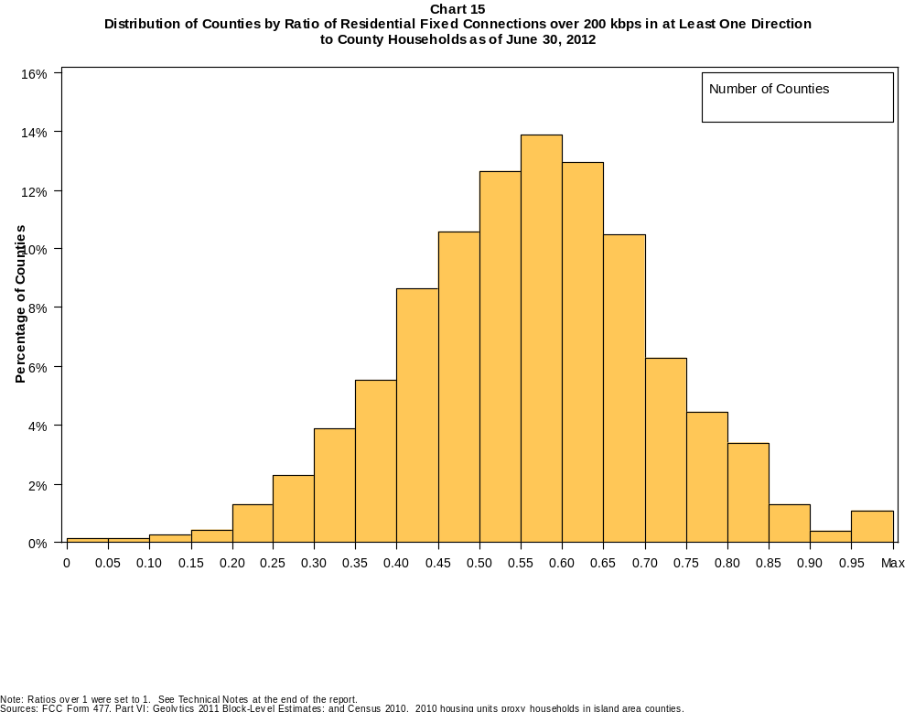

Table 23
Distribution of Counties by Ratio of Residential Fixed Connections over 200 kbps in at Least One Direction
to County Households by Technology as of June 30, 2012

 | Ratio of Residential Fixed Connections to County Households
Technology | Zero | Greater than 0 and no more than 5% | Greater than 5 and no more than 10% | Greater than 10 and no more than 20% | Greater than 20 and no more than 30% | Greater than 30 and no more than 40% | Greater than 40 and no more than 50% | Greater than 50 and no more than 60% | Greater than 60 and no more than 80% | Greater than 80 and no more than 100% | 100% or more
aDSL | 0.5 | 1.8 | 4.9 | 26.1 | 31.4 | 21.2 | 9.4 | 3.4 | 0.9 | 0.3 | 0.1
sDSL | 83.9 | 15.4 | 0.4 | 0.2 | 0.1 | 0.0 | 0.0 | 0.0 | 0.0 | 0.0 | 0.0
Other Wireline | 97.7 | 2.1 | 0.1 | 0.0 | 0.0 | 0.0 | 0.0 | 0.0 | 0.0 | 0.0 | 0.0
Cable Modem | 13.5 | 9.1 | 9.4 | 18.0 | 17.2 | 14.6 | 10.9 | 5.0 | 1.9 | 0.2 | 0.2
FTTP | 57.8 | 29.2 | 4.4 | 3.7 | 2.4 | 1.2 | 0.6 | 0.4 | 0.3 | 0.0 | 0.0
Satellite | 0.5 | 83.2 | 13.0 | 3.0 | 0.1 | 0.1 | 0.0 | 0.0 | 0.0 | 0.0 | 0.0
Fixed Wireless | 43.8 | 44.2 | 7.6 | 3.6 | 0.6 | 0.2 | 0.1 | 0.0 | 0.0 | 0.0 | 0.0
Power Line | 100.0 | 0.0 | 0.0 | 0.0 | 0.0 | 0.0 | 0.0 | 0.0 | 0.0 | 0.0 | 0.0
All Other | 100.0 | 0.0 | 0.0 | 0.0 | 0.0 | 0.0 | 0.0 | 0.0 | 0.0 | 0.0 | 0.0
Total | 0.1 | 0.1 | 0.2 | 0.7 | 3.6 | 9.4 | 19.2 | 26.5 | 34.1 | 5.5 | 0.7

Note: Figures may not sum to totals due to rounding. See Technical Notes at the end of the report.
Sources: FCC Form 477, Part VI; Geolytics 2011 Block-Level Estimates; and Census 2010. 2010 housing units proxy households in island area counties.

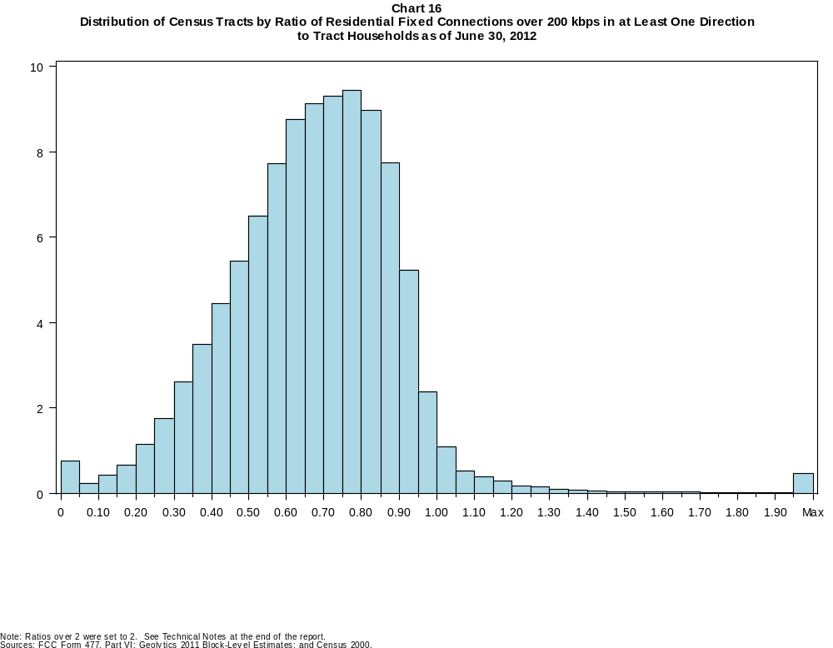

Table 24
Distribution of Census Tracts by Ratio of Residential Fixed Connections over 200 kbps in at Least One Direction
to Tract Households by Technology as of June 30, 2012

 | Ratio of Residential Fixed Connections to Tract Households
Technology | Zero | Greater than 0 and no more than 5% | Greater than 5 and no more than 10% | Greater than 10 and no more than 20% | Greater than 20 and no more than 30% | Greater than 30 and no more than 40% | Greater than 40 and no more than 50% | Greater than 50 and no more than 60% | Greater than 60 and no more than 80% | Greater than 80 and no more than 100% | 100% or more
aDSL | 1.3 | 8.3 | 11.1 | 28.4 | 23.6 | 14.8 | 7.5 | 3.0 | 1.4 | 0.3 | 0.3
sDSL | 96.5 | 3.3 | 0.1 | 0.1 | 0.0 | 0.0 | 0.0 | 0.0 | 0.0 | 0.0 | 0.0
Other Wireline | 99.8 | 0.2 | 0.0 | 0.0 | 0.0 | 0.0 | 0.0 | 0.0 | 0.0 | 0.0 | 0.0
Cable Modem | 5.8 | 3.5 | 2.6 | 8.8 | 15.3 | 18.8 | 17.1 | 13.6 | 11.9 | 1.8 | 0.9
FTTP | 73.2 | 10.7 | 2.0 | 3.0 | 3.4 | 3.4 | 2.3 | 1.2 | 0.6 | 0.1 | 0.0
Satellite | 46.7 | 47.7 | 3.7 | 1.6 | 0.2 | 0.1 | 0.0 | 0.0 | 0.0 | 0.0 | 0.0
Fixed Wireless | 84.4 | 12.3 | 1.7 | 1.2 | 0.3 | 0.1 | 0.0 | 0.0 | 0.0 | 0.0 | 0.0
Power Line | 99.9 | 0.1 | 0.0 | 0.0 | 0.0 | 0.0 | 0.0 | 0.0 | 0.0 | 0.0 | 0.0
All Other | 100.0 | 0.0 | 0.0 | 0.0 | 0.0 | 0.0 | 0.0 | 0.0 | 0.0 | 0.0 | 0.0
Total | 0.6 | 0.2 | 0.3 | 1.1 | 2.9 | 6.1 | 9.9 | 14.2 | 36.6 | 24.4 | 3.7

Note: Figures may not sum to totals due to rounding. See Technical Notes at the end of the report.
Sources: FCC Form 477, Part VI; Geolytics 2011 Block-Level Estimates; and Census 2000.

Table 25
Percentage of Census Tracts with Residential Fixed Connections by Technology as of June 30, 2012
(Connections over 200 kbps in at least one direction)

 | Number of Providers
Technology | Zero | One | Two | Three | Four | Five | Six | Seven or More
aDSL | 1.3 | 48.0 | 35.9 | 12.5 | 1.9 | 0.3 | 0.0 | 0.0
sDSL | 96.5 | 3.3 | 0.2 | 0.0 | 0.0 | 0.0 | 0.0 | 0.0
Other Wireline | 99.8 | 0.2 | 0.0 | 0.0 | 0.0 | 0.0 | 0.0 | 0.0
Cable Modem | 5.8 | 81.4 | 12.3 | 0.5 | 0.0 | 0.0 | 0.0 | 0.0
FTTP | 73.2 | 26.1 | 0.6 | 0.0 | 0.0 | 0.0 | 0.0 | 0.0
Satellite | 46.7 | 24.0 | 26.9 | 2.5 | 0.0 | 0.0 | 0.0 | 0.0
Fixed Wireless | 84.4 | 12.0 | 2.9 | 0.6 | 0.1 | 0.0 | 0.0 | 0.0
Power Line | 99.9 | 0.1 | 0.0 | 0.0 | 0.0 | 0.0 | 0.0 | 0.0
aDSL and/or Cable Modem and/or FTTP | 0.8 | 2.9 | 40.9 | 35.5 | 15.8 | 3.4 | 0.6 | 0.1
Any Technology | 0.6 | 0.6 | 18.4 | 27.6 | 25.9 | 15.6 | 7.1 | 4.2

Note: Figures may not sum to totals due to rounding.
Sources: FCC Form 477, Part VI and Census 2010.

Table 26
Distribution of Counties by Ratio of Residential Fixed Connections to County Households by State as of June 30, 2012
(Connections over 200 kbps in at least one direction)

 |  | Ratio of Residential Fixed Connections over 200 kbps in at Least One Direction to County Households
State | Counties | Zero | Greater than 0 and no more than 5% | Greater than 5 and no more than 10% | Greater than 10 and no more than 20% | Greater than 20 and no more than 30% | Greater than 30 and no more than 40% | Greater than 40 and no more than 50% | Greater than 50 and no more than 60% | Greater than 60 and no more than 80% | Greater than 80 and no more than 100% | 100% or more
Alabama | 67 | 0 | 0 | 0 | 2 | 4 | 9 | 30 | 9 | 13 | 0 | 0
Alaska | 29 | 0 | 0 | 1 | 2 | 1 | 3 | 7 | 0 | 14 | 0 | 1
American Samoa | 5 | 2 | 1 | 0 | 1 | 1 | 0 | 0 | 0 | 0 | 0 | 0
Arizona | 15 | 0 | 0 | 0 | 0 | 0 | 2 | 0 | 7 | 6 | 0 | 0
Arkansas | 75 | 0 | 0 | 0 | 0 | 3 | 23 | 31 | 10 | 8 | 0 | 0
California | 58 | 0 | 0 | 0 | 1 | 0 | 1 | 3 | 8 | 34 | 10 | 1
Colorado | 64 | 0 | 0 | 0 | 0 | 1 | 1 | 8 | 17 | 22 | 9 | 6
Connecticut | 8 | 0 | 0 | 0 | 0 | 0 | 0 | 0 | 0 | 4 | 4 | 0
Delaware | 3 | 0 | 0 | 0 | 0 | 0 | 0 | 0 | 0 | 2 | 1 | 0
District of Columbia | 1 | 0 | 0 | 0 | 0 | 0 | 0 | 0 | 0 | 1 | 0 | 0
Florida | 67 | 0 | 0 | 0 | 0 | 2 | 1 | 13 | 9 | 31 | 9 | 2
Georgia | 159 | 0 | 0 | 1 | 2 | 10 | 18 | 37 | 35 | 47 | 9 | 0
Guam | 1 | 0 | 0 | 0 | 0 | 0 | 0 | 0 | 1 | 0 | 0 | 0
Hawaii | 5 | 0 | 1 | 0 | 0 | 0 | 0 | 0 | 0 | 1 | 3 | 0
Idaho | 44 | 0 | 0 | 0 | 0 | 2 | 4 | 14 | 11 | 12 | 0 | 1
Illinois | 102 | 0 | 0 | 1 | 1 | 2 | 7 | 20 | 38 | 29 | 3 | 1
Indiana | 92 | 0 | 0 | 0 | 0 | 1 | 5 | 23 | 37 | 24 | 2 | 0
Iowa | 99 | 0 | 0 | 0 | 0 | 0 | 0 | 8 | 46 | 43 | 2 | 0
Kansas | 105 | 0 | 0 | 0 | 0 | 0 | 2 | 15 | 37 | 48 | 3 | 0
Kentucky | 120 | 0 | 0 | 0 | 0 | 4 | 10 | 31 | 36 | 36 | 3 | 0
Louisiana | 64 | 0 | 0 | 0 | 0 | 4 | 10 | 18 | 14 | 18 | 0 | 0
Maine | 16 | 0 | 0 | 0 | 0 | 0 | 0 | 0 | 2 | 10 | 4 | 0
Maryland | 24 | 0 | 0 | 0 | 0 | 0 | 0 | 4 | 1 | 14 | 5 | 0
Massachusetts | 14 | 0 | 0 | 0 | 0 | 0 | 0 | 0 | 0 | 7 | 4 | 3
Michigan | 83 | 0 | 0 | 0 | 0 | 2 | 7 | 15 | 29 | 27 | 3 | 0
Minnesota | 87 | 0 | 0 | 0 | 0 | 0 | 1 | 6 | 28 | 50 | 2 | 0
Mississippi | 82 | 0 | 0 | 0 | 2 | 15 | 30 | 17 | 11 | 6 | 1 | 0
Missouri | 115 | 0 | 0 | 1 | 1 | 3 | 16 | 33 | 39 | 20 | 2 | 0
Montana | 56 | 0 | 0 | 0 | 0 | 0 | 0 | 10 | 24 | 22 | 0 | 0
Nebraska | 93 | 0 | 0 | 0 | 0 | 0 | 7 | 17 | 35 | 33 | 1 | 0

Table 26 - Continued
Distribution of Counties by Ratio of Residential Fixed Connections to County Households by State as of June 30, 2012
(Connections over 200 kbps in at least one direction)

 |  | Ratio of Residential Fixed Connections over 200 kbps in at Least One Direction to County Households
State | Counties | Zero | Greater than 0 and no more than 5% | Greater than 5 and no more than 10% | Greater than 10 and no more than 20% | Greater than 20 and no more than 30% | Greater than 30 and no more than 40% | Greater than 40 and no more than 50% | Greater than 50 and no more than 60% | Greater than 60 and no more than 80% | Greater than 80 and no more than 100% | 100% or more
Nevada | 17 | 0 | 0 | 0 | 0 | 0 | 4 | 3 | 3 | 7 | 0 | 0
New Hampshire | 10 | 0 | 0 | 0 | 0 | 0 | 0 | 0 | 1 | 4 | 5 | 0
New Jersey | 21 | 0 | 0 | 0 | 0 | 0 | 0 | 0 | 0 | 8 | 12 | 1
New Mexico | 33 | 0 | 0 | 0 | 0 | 2 | 7 | 7 | 8 | 7 | 2 | 0
New York | 62 | 0 | 0 | 0 | 0 | 0 | 1 | 0 | 9 | 41 | 10 | 1
North Carolina | 100 | 0 | 0 | 0 | 0 | 0 | 3 | 23 | 25 | 37 | 11 | 1
North Dakota | 53 | 0 | 0 | 0 | 0 | 0 | 1 | 4 | 9 | 35 | 4 | 0
Northern Mariana Isl | 4 | 1 | 0 | 0 | 3 | 0 | 0 | 0 | 0 | 0 | 0 | 0
Ohio | 88 | 0 | 0 | 0 | 0 | 0 | 3 | 11 | 27 | 45 | 2 | 0
Oklahoma | 77 | 0 | 0 | 0 | 0 | 8 | 17 | 20 | 22 | 10 | 0 | 0
Oregon | 36 | 0 | 0 | 0 | 0 | 0 | 1 | 3 | 13 | 19 | 0 | 0
Pennsylvania | 67 | 0 | 0 | 0 | 0 | 0 | 3 | 1 | 12 | 38 | 11 | 2
Puerto Rico | 78 | 0 | 0 | 0 | 0 | 18 | 21 | 29 | 9 | 1 | 0 | 0
Rhode Island | 5 | 0 | 0 | 0 | 0 | 0 | 0 | 0 | 0 | 3 | 2 | 0
South Carolina | 46 | 0 | 0 | 0 | 0 | 2 | 9 | 8 | 14 | 11 | 2 | 0
South Dakota | 66 | 0 | 0 | 0 | 0 | 1 | 4 | 5 | 21 | 32 | 3 | 0
Tennessee | 95 | 0 | 0 | 0 | 1 | 4 | 15 | 36 | 23 | 15 | 1 | 0
Texas | 254 | 0 | 0 | 0 | 0 | 11 | 33 | 73 | 71 | 60 | 5 | 1
Utah | 29 | 0 | 0 | 0 | 0 | 1 | 2 | 0 | 9 | 15 | 1 | 1
Vermont | 14 | 0 | 0 | 0 | 0 | 0 | 0 | 0 | 1 | 8 | 5 | 0
Virgin Islands | 3 | 0 | 0 | 0 | 0 | 1 | 2 | 0 | 0 | 0 | 0 | 0
Virginia | 134 | 0 | 0 | 1 | 6 | 11 | 12 | 21 | 38 | 29 | 16 | 0
Washington | 39 | 0 | 0 | 0 | 0 | 1 | 3 | 1 | 9 | 24 | 1 | 0
West Virginia | 55 | 0 | 0 | 0 | 0 | 1 | 5 | 9 | 24 | 15 | 1 | 0
Wisconsin | 72 | 0 | 0 | 0 | 0 | 0 | 0 | 4 | 19 | 46 | 2 | 1
Wyoming | 23 | 0 | 0 | 0 | 0 | 0 | 1 | 3 | 6 | 12 | 1 | 0
Total | 3,234 | 3 | 2 | 5 | 22 | 116 | 304 | 621 | 857 | 1104 | 177 | 23

Note: Figures may not sum to totals due to rounding. See Technical Notes at the end of the report.
Sources: FCC Form 477, Part VI (Connections); Geolytics 2011 Block-Level Estimates (Households for U.S. and District of Columbia); Census 2010 (Housing units for Puerto Rico, American Samoa,
Guam, Northern Mariana Islands and U.S. Virgin Islands).

Table 27
Distribution of Census Tracts by Ratio of Residential Fixed Connections to Tract Households by State as of June 30, 2012
(Connections over 200 kbps in at least one direction)

 |  | Ratio of Residential Fixed Connections over 200 kbps in at Least One Direction to Tract Households
State | Tracts | Zero | Greater than 0 and no more than 5% | Greater than 5 and no more than 10% | Greater than 10 and no more than 20% | Greater than 20 and no more than 30% | Greater than 30 and no more than 40% | Greater than 40 and no more than 50% | Greater than 50 and no more than 60% | Greater than 60 and no more than 80% | Greater than 80 and no more than 100% | 100% or more
Alabama | 1,179 | 4 | 2 | 1 | 30 | 92 | 176 | 233 | 207 | 318 | 97 | 19
Alaska | 167 | 2 | 2 | 1 | 5 | 6 | 7 | 11 | 20 | 79 | 23 | 11
American Samoa | 18 | 3 | 6 | 1 | 2 | 2 | 0 | 2 | 1 | 0 | 1 | 0
Arizona | 1,526 | 18 | 14 | 7 | 18 | 40 | 81 | 134 | 200 | 525 | 418 | 71
Arkansas | 686 | 0 | 2 | 1 | 22 | 66 | 125 | 146 | 109 | 162 | 41 | 12
California | 8,036 | 40 | 14 | 13 | 56 | 79 | 207 | 483 | 841 | 2,938 | 3,055 | 310
Colorado | 1,249 | 12 | 0 | 2 | 3 | 9 | 27 | 79 | 158 | 456 | 427 | 76
Connecticut | 829 | 3 | 0 | 0 | 0 | 3 | 14 | 45 | 60 | 273 | 408 | 23
Delaware | 215 | 1 | 0 | 0 | 1 | 0 | 2 | 16 | 26 | 78 | 70 | 21
District of Columbia | 179 | 1 | 0 | 0 | 0 | 0 | 3 | 22 | 26 | 75 | 46 | 6
Florida | 4,199 | 30 | 3 | 4 | 11 | 51 | 137 | 332 | 559 | 1,690 | 1,131 | 251
Georgia | 1,964 | 10 | 5 | 1 | 23 | 78 | 187 | 290 | 316 | 650 | 352 | 52
Guam | 56 | 6 | 2 | 0 | 4 | 2 | 2 | 0 | 1 | 3 | 3 | 33
Hawaii | 326 | 7 | 1 | 1 | 3 | 0 | 2 | 11 | 23 | 128 | 108 | 42
Idaho | 298 | 1 | 0 | 1 | 0 | 7 | 19 | 46 | 87 | 113 | 20 | 4
Illinois | 3,121 | 7 | 5 | 3 | 26 | 80 | 249 | 376 | 485 | 1,166 | 674 | 50
Indiana | 1,508 | 3 | 2 | 3 | 5 | 35 | 100 | 262 | 357 | 542 | 177 | 22
Iowa | 825 | 2 | 1 | 1 | 1 | 8 | 20 | 82 | 212 | 420 | 69 | 9
Kansas | 770 | 7 | 1 | 0 | 4 | 14 | 48 | 92 | 175 | 275 | 130 | 24
Kentucky | 1,115 | 8 | 0 | 2 | 14 | 43 | 87 | 192 | 227 | 382 | 130 | 30
Louisiana | 1,136 | 10 | 0 | 2 | 16 | 60 | 154 | 214 | 216 | 350 | 100 | 14
Maine | 351 | 0 | 0 | 0 | 0 | 2 | 5 | 22 | 40 | 178 | 77 | 27
Maryland | 1,394 | 7 | 0 | 1 | 1 | 16 | 67 | 90 | 128 | 467 | 560 | 57
Massachusetts | 1,471 | 9 | 0 | 0 | 1 | 5 | 6 | 33 | 107 | 572 | 658 | 80
Michigan | 2,767 | 24 | 1 | 4 | 40 | 172 | 251 | 290 | 362 | 1,001 | 586 | 36
Minnesota | 1,335 | 4 | 0 | 2 | 6 | 6 | 31 | 106 | 257 | 621 | 289 | 13
Mississippi | 661 | 3 | 1 | 6 | 18 | 87 | 153 | 120 | 93 | 134 | 32 | 14
Missouri | 1,393 | 3 | 4 | 4 | 16 | 93 | 138 | 201 | 272 | 433 | 205 | 24
Montana | 271 | 2 | 0 | 2 | 2 | 3 | 15 | 32 | 74 | 110 | 23 | 8
Nebraska | 532 | 2 | 0 | 1 | 0 | 2 | 25 | 58 | 114 | 216 | 91 | 23

Table 27 - Continued
Distribution of Census Tracts by Ratio of Residential Fixed Connections to Tract Households by State as of June 30, 2012
(Connections over 200 kbps in at least one direction)

 |  | Ratio of Residential Fixed Connections over 200 kbps in at Least One Direction to Tract Households
State | Tracts | Zero | Greater than 0 and no more than 5% | Greater than 5 and no more than 10% | Greater than 10 and no more than 20% | Greater than 20 and no more than 30% | Greater than 30 and no more than 40% | Greater than 40 and no more than 50% | Greater than 50 and no more than 60% | Greater than 60 and no more than 80% | Greater than 80 and no more than 100% | 100% or more
Nevada | 683 | 5 | 0 | 3 | 9 | 25 | 45 | 73 | 92 | 252 | 151 | 28
New Hampshire | 294 | 2 | 0 | 1 | 0 | 0 | 0 | 6 | 17 | 114 | 139 | 15
New Jersey | 2,004 | 8 | 1 | 2 | 1 | 0 | 10 | 32 | 112 | 754 | 984 | 100
New Mexico | 499 | 5 | 11 | 4 | 9 | 27 | 53 | 86 | 87 | 155 | 47 | 15
New York | 4,900 | 65 | 2 | 9 | 20 | 37 | 119 | 158 | 452 | 2,295 | 1,541 | 202
North Carolina | 2,183 | 14 | 1 | 1 | 9 | 52 | 134 | 282 | 370 | 719 | 421 | 180
North Dakota | 205 | 0 | 0 | 0 | 0 | 3 | 6 | 17 | 34 | 106 | 28 | 11
Northern Mariana Isl | 22 | 3 | 2 | 0 | 1 | 3 | 0 | 0 | 2 | 1 | 1 | 9
Ohio | 2,946 | 6 | 0 | 2 | 12 | 76 | 214 | 319 | 495 | 1,226 | 541 | 55
Oklahoma | 1,046 | 1 | 9 | 12 | 34 | 76 | 136 | 177 | 171 | 265 | 138 | 27
Oregon | 827 | 2 | 0 | 0 | 1 | 1 | 13 | 53 | 166 | 419 | 165 | 7
Pennsylvania | 3,217 | 13 | 2 | 3 | 20 | 34 | 78 | 220 | 497 | 1,455 | 749 | 146
Puerto Rico | 903 | 15 | 2 | 27 | 167 | 171 | 176 | 116 | 79 | 54 | 31 | 65
Rhode Island | 241 | 0 | 0 | 0 | 0 | 0 | 0 | 3 | 23 | 129 | 76 | 10
South Carolina | 1,097 | 9 | 0 | 0 | 12 | 60 | 121 | 187 | 186 | 322 | 136 | 64
South Dakota | 222 | 1 | 0 | 0 | 1 | 3 | 8 | 20 | 44 | 113 | 28 | 4
Tennessee | 1,497 | 14 | 2 | 3 | 22 | 92 | 181 | 299 | 284 | 424 | 149 | 27
Texas | 5,253 | 29 | 11 | 33 | 104 | 269 | 621 | 769 | 739 | 1,433 | 1,030 | 215
Utah | 588 | 5 | 1 | 3 | 2 | 5 | 6 | 33 | 80 | 281 | 143 | 29
Vermont | 184 | 1 | 0 | 0 | 0 | 0 | 1 | 2 | 18 | 101 | 48 | 13
Virgin Islands | 29 | 0 | 0 | 1 | 4 | 6 | 4 | 3 | 4 | 4 | 0 | 3
Virginia | 1,895 | 18 | 3 | 12 | 34 | 68 | 98 | 182 | 226 | 472 | 693 | 89
Washington | 1,446 | 1 | 0 | 2 | 7 | 19 | 42 | 80 | 163 | 646 | 456 | 30
West Virginia | 484 | 0 | 4 | 6 | 17 | 13 | 39 | 73 | 95 | 177 | 41 | 19
Wisconsin | 1,393 | 2 | 3 | 1 | 6 | 30 | 73 | 116 | 251 | 677 | 212 | 22
Wyoming | 132 | 1 | 0 | 0 | 3 | 3 | 6 | 10 | 20 | 71 | 17 | 1
Total | 73,767 | 449 | 120 | 189 | 823 | 2,134 | 4,522 | 7,336 | 10,460 | 27,020 | 17,966 | 2,748

Note: Figures may not sum to totals due to rounding. See Technical Notes at the end of the report.
Sources: FCC Form 477, Part VI (Connections); Geolytics 2011 Block-Level Estimates (Households for U.S. and District of Columbia); Census 2000 (Households for Puerto Rico, American Samoa,
Guam, Northern Mariana Islands and U.S. Virgin Islands).

